RESEARCH PROJECT – SOFTWARE ENGINEERING

WEB-BASED BLOOD DONOR MANAGEMENT SYSTEM
WITH ENHANCED MACHINE LEARNING
AT

SKYLINE UNIVERSITY NIGERIA

Submitted by
ABDALLAH IBRAHIM ABDALLAH
ID: 1110

Under the Guidance of
DR. VIJAY ARPUTHARAJ, HOD – COMPUTER SCIENCE, SKYLINE UNIVERSITY NIGERIA.

In partial fulfillment of the requirements for the award of the degree of
BSc – Software Engineering
SSIT – School of Science and Information Technology

JULY 2022

CERTIFICATE
This is to certify that the RESEARCH PROJECT REPORT entitled "WEB BASED BLOOD DONOR MANAGEMENT SYSTEM WITH ENHANCED MACHINE LEARNING" in partial fulfilment of the requirements for the award of the Degree of B.Sc Software Engineering is a record of original training undergone by ABDALLAH IBRAHIM ABDALLAH (ID: 1110) during the year 2022 of her/his study in the Department of Computer Science, Skyline University, Nigeria under my supervision and the report has not formed the basis for the award of any Degree/Fellowship or other similar title to any candidate of any University.

Signature of the Supervisor
(Guide name with qualification and designation)

Place:
Date:

Countersigned
Head of the Department

Submitted to the Department of Computer Science, Skyline University, Nigeria for the examination held on

INTERNAL EXAMINER EXTERNAL EXAMINER

DECLARATION

I, ABDALLAH IBRAHIM ABDALLAH, hereby declare that the RESEARCH PROJECT REPORT, entitled " WEB BASED BLOOD DONOR MANAGEMENT SYSTEM WITH ENHANCED MACHINE LEARNING " , submitted to the Skyline University, Nigeria in partial fulfilment of the requirements for the award of the Degree of software engineering is a record of original training undergone by me during the period Mar 2022 – Aug 2022 under the supervision and guidance of Dr. Vijay Arputharaj, HOD – Computer Science, Department of Computer Science, Skyline University, Nigeria and it has not formed the basis for the award of any Degree/Fellowship or other similar title to any candidate of any University.

Signature of the Student
Place:
Date :

ACKNOWLEDGEMENT

I express my sincere thanks to ALH..Ibrahim Abdallah Bagwanje ,General Manager / CEO/, ZIBA TEX NIG LTD, Kano, for his support and encouragement towards my study.
I place on record my profound thanks to The Vice-Chancellor, The Registrar and The Director - Academic Affairs and The Corporate Affairs, Dean – SAMSS / SSIT Skyline University, Kano, Nigeria for giving me an opportunity to undertake my SWIES work in this prestigious institution.

I am greatly indebted to my Head of the Department Computer Science for his advice, constant words of encouragement, able guidance and expert is which have tremendously helped me in completing this study.

I express my heartfelt thanks to Dr. Vijay, Research Project Supervisor, for his valuable suggestions and moral support in different stages of my SWIES work. I am ever grateful to my distinguished Supervisor Dr.Vijay, HOD – Computer Science, Skyline University, Nigeria for their continuous support in materializing the SIWES training work in successful manner.

I extend my thanks to all the employees of Skyline University Nigeria who readily gave me their fullest cooperation by willingly answering all the queries in connection with my training work.

Student Name: Abdallah Ibrahim Abdallah

CONTENT

CHAPTER | PARTICULARS | PAGE
 | Certificate | (i)
 | Company Certificate | (ii)
 | Declaration | (iii)
 | Acknowledgement | (iv)
 | Contents | (v)
 | List of Tables | (vi)
 | List of Figures/Charts | (vii)
 | List of Abbreviations & Appendix | (viii)
 | Executive Summary / Abstract
1 | INTRODUCTION
1.1 | Introduction to the Research Study | 2  2  5  6  6  7  7  8
1.2 | Background of the Research Study
1.3 | Aim and Objectives
1.4 | Problem Statement
1.5 | Scope & Limitation
1.6 | Significance of the Study
1.7 | Motivation
1.8 | Outline of the Research
2 | LITERATURE SURVEY
2.1 | Introduction | 9  10  14  14  14  14
2.2 | Literature related to the Topic
2.3 | Literature related to the Method & Results
2.4 | Research Gaps
2.5 | Summary of the Literature Reviewed
3 | METHODOLOGY
3.1 | Methodology | 21 23
3.2 | Selection of Method/ Data/ Algorithms

3.3  3.4  3.5 | Implementation of Project  UML Diagram  Testing Methods | 26  28  34
4 | SUMMARY OF RESULTS
4.1  4.2  4.3 | Results  Comparison of Results Recommendation | 38  38  38
5 | CONCLUSION, SUMMARY & FUTURE WORK
5.1  5.2  5.3 | Summary  Conclusion  Future Enhancements | 40  41  42
 | REFERENCES | 43
 | APPENDICES | 45
I | Plagiarism Report | 51
II | Work Plan | 52

List of Table

Table No. | Particulars / Title of the Table | Page No.
1.1 | Literature Review | 14
1.2 | Implementation Summary | 24
2.1 | Project Work Plan | 27
2.2 | Component Of Use Case Diagram | 29
3.1 | Database | 30
3.2 | Unit Test Case | 34
4.1 | Integration Test Case | 36
4.2 | Comparisons | 38

List Of Abbreviation

Abbreviated Form | Expanded Form
CSS | Cascading Style Sheet
FK | Foreign Key
GUI | Graphical User Interface
HTML | Hypertext markup language
IDE | Integrated Development Environment
PHP | Hypertext Preprocessor
PCRE | Perl Compatible Regular Expression
PK | Primary Key
UML | Unified Modelling Language

List of appendix
APPENDIX NO | APPENDIX DETAILS
1 | Appendix 1 Home Page
2 | Appendix 2 Admin Login Page
3 | Appendix 3 Become A Donor
4 | Appendix 4 Report/ Request
5 | Appendix 5 Contact Us
6 | Appendix 6 About Us
7 | Appendix 7 Admin Dashboard
8 | Appendix 8 Database Design
9 | Appendix 9 Database Design
10 | Appendix 10 Sample Code
11 | Appendix 11 Sample Code
12 | Appendix 12 Sample Code

ABSTRACT
In modern days, the number of blood banks are limited in developing and the least developed countries. It is hard to find a blood donor with exact blood group in a critical/crucial moment. Patients experience great pain and sometimes die. Accidents, ongoing medical interventions, and planned surgery all lead to emergencies that require immediate use of a particular blood type. Easier access to blood from the surrounding area / location was considered. In this project, the proposed web-based application was created to help in saving people lives. This allows anyone to find their preferred blood type at the nearest location or donate blood to selected parties. Today, many people access the Internet through smartphones and PCs with different operating systems. The system will be built and accessible on multiple platforms, including Windows computers, Apple products, and Android and iOS mobile devices. An administrator is the one who is capable of managing donor and also the rest of the software is responsible for managing the donors and also the whole system. This system is developed using some of the following programming languages which are CSS, JAVASCRIPT, BOOSTRAP which serve as my frontend and MYSQL, PHP which all serve as my backend. I also used some of software development tools such as Compilers, GUI designers, IDE and more.

CHAPTER ONE
INTRODUCTION

1.1 Introduction To Research Study
According to Wikipedia, the process of recruiting blood donors (BDR) is the act of taking blood samples from willing donors (BD) in preparation for blood transfusions (2006). Blood donation helps people recover and maintain their health after procedures, complicated surgeries, and difficult pregnancies in Nigeria, where it saves millions of lives every year. The normal whole-blood donation is just one pint, despite the fact that an adult possesses roughly 10 pints of blood.

1.2 Background of Study
The significance of blood to the human body can't be hyped up hence the widely wide-spread need for safe blood from blood donors. This is critical each for remedies and pressing interventions. It can help sufferers tormented by existence-threatening situations live longer and with a better pleasant of life as well as assisting complicated clinical and surgical tactics and has an essential, existence-saving function in maternal and neonatal care. However, get entry to to safe blood continues to be a privilege of the few. Most low- and middle-earnings international locations warfare to make safe blood available due to the fact donations are low and equipment to test blood scarce.
Between low- and excessive-profits international locations, there is a clear distinction in the availability of blood. According to statistics, there are 32.6 blood donations made in keeping with 1000 humans in excessive-profits nations, compared to 4.4 donations made according to a thousand humans in low-income ones.
Donating blood has advantages for the donor's health further to the best it does for others. Studies have shown that donating blood can enhance coronary heart health with the aid of reducing cholesterol and reducing the risk of a coronary failure. It is becoming an increasing number of widely understood that donating blood can be a selfless act of solidarity, and that the offerings that provide secure blood and blood merchandise are an essential issue of each healthcare gadget.
Donating blood takes only approximately 10-15 minutes. In an effort to donate blood, the donor have to be in excellent fashionable fitness, weigh no less than 110 pounds (50kg), and be no less than 18 years vintage. Eat a decent breakfast or lunch, drink many fluids and find lots of sleep the night time earlier than donating blood. Everyone who's eligible can donate blood, but the stipulated hints ought to be strictly adhered to, as there are elements which could save you a non-public from being a donor. These encompass, however don't appear to be restrained to, unique medical issues, drugs, precise worldwide tour, tattoos and piercings, being pregnant, and anemia.
Between 2008 and 2015, there has been an growth of 11.6 million voluntary unpaid blood donations said globally, with the south-east Asian place recording the very best increase (83 percentage) and the African region the bottom (nine percentage ). It is obvious that there's a terrible blood donation lifestyle inside the location, and severa other research have proven that this tradition may be fueled via superstitious, non secular, and religious ideals.
When blood is extracted, the donor's body starts making more blood right once to replace what become lost. New cells are produced by means of the marrow within forty eight hours of donation, and therefore the purple blood cells misplaced for the duration of donation are completely changed. Donating blood to keep away from losing a person’s existence is circuitously saving your very own. Give blood and make the globe a healthier vicinity!
The automation of the device the usage of modern it's progressed the standard of provider. Secondly, with the usage of IT, now applicable and timely donor reports can without problems be generated and therefore facilitating making plans and selection.
Modern database systems are mainly powerful at processing big quantities of information from a variety of assets. Any facts that may be described in a relation may be entered into the database gadget, however to make the information available at the Web, use a unique database algebra referred to as SQL to get entry to the database and markup including HTML and XML. Need to convert to language. To understand this gadget, you first want to apprehend what the web is and a way to connect a database to the internet. The World Wide Web is a software surroundings built on an Internet computer network. It is officially described these days as a “wide-region hypermedia retrieval initiative aiming to give time-honored access to a huge universe of files and has a diffusion of makes use of in the course of the sector. However, with the intention to completely take benefit of those uses one should simply be connected to the Internet and must use some type of software program package deal (Web Browser) that is familiar with markup languages (i.E. Hypertext, hypermedia) An extra requirement of the machine is the capability to combine with Endnote software program. The downside of the use of this software tool is that it could most effective be run on one pc, so customers who aren't the use of a PC with Endnote hooked up can not get right of entry to the database. Therefore, it is vital to offer a "bridge" between the net-based totally DBMS and the Endnote software gear database device in order that bibliographic facts can be transferred (imported / exported) among the above structures as needed. This integration now not most effective eases the need for continuity, but also ensures a good level of standardization for the machine and its users.

There are many (and widely studied) strategies for integrating net-primarily based faces into databases. Analyzing the strengths and weaknesses of each generation makes it less difficult for structures below development to maximise web-to-database access and endnote compatibility. Using greater automatic capabilities for public purposes will extensively improve this device by using decreasing the workload of sure employees and increasing their productiveness.

1.3 Aim and Objective
Aim

The purpose of this study is to create an electronic information system for blood donation management and use the latest technology to support the management, scheduling and information sharing of blood donation registries in a more sensitive, convenient and secure way.

Objectives
Conducting research on blood donor management
Designing an electronic blood donor management system
To make it easier for administrators to search, match, and request blood.
To provide a system with features to help donors easily access and manage their information.

1.4 Statement of the Problem
The Nigerian donor recruitment management system displayed a great deal of inefficiency and ineffectiveness, which had a far-reaching impact on the decisions made by management. The manual method, which supported paper cards to collect donor information, maintain track of blood donors, and communicate findings to BDs, had flaws that required IT-based alternatives. The system was characterized by delays and occasionally failures to access historical information, inaccuracies in data input and human interpretation of findings, and a lack of secrecy and confidentiality of records due to easy access to the records by unauthorized parties. Therefore, administrative decisions such as blood distribution to hospitals and mobilization / awareness raising of blood donors were not made on the basis of actual facts. In such a system, another management challenge was to quickly generate blood group reports for a large number of blood donors in the field. In fact, it was envisioned to apply IT-based solutions to improve the system. Therefore, the current system has been reviewed and effective and robust donor management data systems have been developed to assist management in implementing strategic plans to achieve all goals.

1.5 Scope
The study geographically limited itself at the Nigeria blood donation/collection centres. The collection and distribution of blood units for BDR operations were given additional attention. The development and deployment of an electronic management information system that automates the collection of data on blood donors and the dissemination of findings were particularly stressed in the study. Consequently, the planning and decision-making processes will be facilitated and sped up as a result of the fast, secure, private, and trustworthy reports.

1.6 Significance of the Study
The study is very important to the Blood bank in Nigeria, because it aimed at addressing problems of security, secrecy and confidentiality of blood donor records. It also made an effort to examine any delays, mistakes, discrepancies, or lack of timely access to historical documents that may have a far-reaching effect on planning and decision-making. The study's findings led to the following advantages:
Based on hospital needs, it has made it easier to regulate and distribute blood across the nation.
The system's authorized users will have instant access to medical records and automated data collection.
By delivering fast, secure, and more private reports on blood donation to management, it will keep enhancing the planning and decision-making process.
Due to the quick and simple compilation of management reports by the pertinent institutions, it would also improve the delivery of medical services.
1.7 Motivation
The thing that motivate me most to make this software is that, my friends mother died due to lack of blood at Malan Aminu Kano International Hospital. She died because there was not a proper organization of blood management in the hospital; and there was no available donors in the hospital.

1.8 Outline of Report
The system can generate a request to summarize all records including blood donation, blood request for the administrator.
In the first chapter I have stated clearly about the purpose and introduce the benefits of web based blood donor management system with its mission and vision.
In the second chapter I had stated clearly some literatures related to web based blood donor management and also reviewed it in other to make an enhanced updated software.
In third chapter, all the method used in creating this software are mentioned, the tools used, the programming languages such as frontend and backend.
In my chapter four, some comparisons between the old and updated software are mentioned with some recommendations.
Lastly chapter five, it talks about the summary of the project, conclusion with some reference.

CHAPTER TWO

LITERATURE REVIEW

2.1 Introduction
The main reasons for blood donation and its relative importance Reviewed by Bani and Giussani (2011). In addition, it is also documented Tissues at the blood sampling stage can affect donors availability. Inadequate treatment, inadequate staff skills, and bad experience are the main causes Reasons for not returning to donations (Schereiber et al. 2003). Even in long lines Time is negatively correlated with BD satisfaction (McKeeveretal. 2006; cat et al. 2007). Therefore, well organized donation management has a strong impact about the availability of blood bags, and perhaps the motives of donors
A donor is asked to supply personal (such as name, address, age, employment, and gender) and medical/health (such as diagnosis, lab results, and therapies) data when they sign up for the first time in the system. These data are digitally captured. From blood collection to blood distribution and transfusion, digital registration offers good cycle traceability. The registration process also involves a doctor's appointment and blood tests. If a donor is accepted, blood donation facilities verify that the donor gives the first donation within a short period of time after being accepted. Sometimes a donation comes right after the initial visit. Before every examination or donation, a visit is also done, during which the donor is reassessed and his or her personal information is updated.
Numerous management issues occur, both at the planning level (such as the location of the blood collection center or staff sizing) and at the operating level (e.g, appointment scheduling). Despite the significant influence of donor arrivals on the performance of the system as a whole, very few articles concentrate on optimization difficulties that arise in the registration and donation phase. In order to examine scheduling techniques for donors coming at a Red Cross blood drive in terms of mean travel times, Michaels et al. (1993) created a simulation study. They then determined which scheduling strategy was the most efficient.
Finally, online applications and database systems for donor and bag management are also being considered (Chauetal. 2010; Khanand Qureshi 2009; Kulshreshtha and Maheshwari 2011).
2.2 Literature Review Related To The Topic
Blood collection centers should be located according to accessibility from the hospital to improve the overall performance of the system. In addition, centers are typically subject to regulatory control to ensure the highest quality and safety of blood products. They ensure that blood bags are manufactured according to standardized processes to achieve uniformity of each product (Council of Europe 2007).
Despite the importance of this stage, there is little literature on planning blood sampling systems (Oforietal. 2005; WHO2008; Lieshout-Krikkeetal. 2013). De Angelis et al. (2003) We proposed a probabilistic method for analyzing and certifying the optimal configuration of a server by integrating simulation and optimization of a blood transfusion center in Rome. After collecting the screening phase begins with several tests for infectious diseases. B. HIV, hepatitis B and C, syphilis. They are repeated on all blood samples taken and are generally the same worldwide. Based on the screening results, blood bags are approved for clinical use and manufacture or discarded (WHO2008,2010). An effective and well-organized screening program and a high quality system are essential to provide patients with a safe blood bag and meet their blood transfusion needs.

Blood Donor Systems: Challenges and Successes
Once collected from donors at nearby or network blood centres, blood need to be stored in storage centres or TC earlier than it perishes. These places function a depot until the blood is distributed to the call for factors and sometimes cope with checking out of the blood merchandise.
If TC centres do now not coincide, blood must be transported. Although transportation is as an alternative simple undertaking in this phase due to the fact all accrued luggage are normally addressed to a huge TC or garage centre from all BD centres within the related territory, transportation should be carefully carried out as the blood need to be stored earlier than perishing and calls for specific transportation conditions. In efﬁcient and insufficient transportation might also lessen the satisfactory of end user care and boom charges. There isn't plenty literature to be had approximately blood transportation between collection and garage centres; at the opposite, many papers on blood transportation recognition at the distribution to hospitals (see subsection “Distribution and Utilization”). Ghandforoush and Sen (2010) used a deterministic non-convex integer optimization model to time table the trip transportation of complete blood merchandise from the gathering factors to the regional processing centres.
Blood distribution
The presence of blood collection vehicles is likewise taken into consideration in blood bag transportation. Ekici and Ozener (2014) deﬁned a variation of the Vehicle Routing Problem, i.E., the Maximum Blood Collection Problem (MBCP), in which blood accumulated in a fixed of blood donation web sites is delivered with a ﬂeet of series cars to a single processing centre. Usually, there's no ability hassle on the cars because of small length of the blood collection luggage (Yi 2003; Doerner et al.2008). On the opposite, time constraints are crucial because donated blood has to be brought to the processing centre inside a positive amount of time.
More interest has been paid to the garage of blood products. During the past 20 years signiﬁcant progresses have been made in the era of blood component preparation and storage (McCullough 2005; Blajchman et al. 1979). Belien Forcé (2012) blanketed several works of their survey
The remaining step of the BD chain includes distribution and usage, which involve several management troubles as distinctive underneath. Distribution is tremendously critical for efﬁcient blood usage and should meet the demand, that is often unsure and requires correct predictions. Demand Prediction for Blood Products Several works include an evaluation of the call for, even if popular papers that only awareness on a stochastic prediction of the demand aren't to be had.
Mobile technology can offer a better alternative to the URCS blood donor system, which required counselors to record blood donor findings on sheets of paper that were easily damaged by weather, mice, and unauthorized individuals. This is due to the fact that it offers security, upholds confidentiality, consistency, and secrecy as required for medical records.
Distribution starts with the turning in of additives to hospitals, wherein they are transfused into sufferers. TCs are normally answerable for the provisioning of blood products to hospitals, and the brought portions are limited through the shelf-life of blood merchandise as well as with the aid of the retaining ability. Two styles of blood distribution systems have been mentioned with the aid of Hirsch and Cazal (1981): the reactive kind, wherein the inventory stage of the health center is managed with recognize to call for, and the predictive type, wherein the demand is ﬁxed on schedule.
Prastacos and Brodheim (1980) targeted on a deterministic mathematical programming model, whose target is to streamline the distribution of the regional blood assets even as viewing plan commitments. It is characterised by using a centralized control of blood in preference to an character hospitals control, pre-scheduled deliveries, and a distribution machine wherein blood is turned around some of the hospitals.
Generally, redistributing the blood amongst hospitals is similarly critical for preventing out dating. In the event that there is a pressing want of a particular blood kind in a sanatorium, they'll use the blood with the nearest decay date from an alternative facility to keep away from spoilage of blood devices. Kendall and Lee (1980) targeted on this redistribution trouble: their model has extraordinary desires, e.G., anticipation of blood shortages and overages in hospitals, minimization of the amount of vintage units, and minimization of the operating prices.
Recently, Le et al. (2013) combined stock and routing management into one model: they proposed a column technology-based totally heuristics to clear up the trouble,and showed signiﬁcant financial savings while the use of their version. Shen et al. (2003) provided a joint area-inventory model for blood distribution device, with non-linear operating-inventory fees and non-linear protection stock inventory costs.

2.3 Literature Related To The Method And Result, Gaps, Summary
Table 2.1 literature review
S/N | Author | Article | Content summary
1 | Bani and Giussani | Motivation in Italian whole blood donors and the role of commitment.  Psychol. Health Med. | In this article he documented the importance of blood donor
2 | Schereiber, G.B., Glynn, S.A., Damesyn, M.A., et al.: | Lapsed donors: an untapped resource.  Transfusion 43(1), 17–24 (2003) | Reasons why people do not return to blood donation center
3 | McKeever, T., Sweeney, M.R., Staines, A.: | An investigation of the impact of prolonged waiting  times on blood donors in Ireland. Vox Sang. 90(2), 113–118 (2006) | Importance of well organized blood center
4 | Michaels, J.D., Brennan, J.E., Golden, B.L.: | A simulation study of donor scheduling systems for  the American Red Cross. Comput. Oper. Res. 20(2), 199–213 (1993) | He created a study and specify which strategy is most efficient
5 | Chau, M., Cheng, E. Chan, C.W.: | Data analysis for healthcare: a case study in blood donation center  analysis. In: Proceedings of 16th Americas Conference on Information Systems AMCIS, p. | Importance of online software for blood donation
6 | Khan, A.R., Qureshi, M.S.: | Web-based information system for blood donation. Int. J. Digit.  Content Technol. Appl. 3(2), 137–142 (2009) | He also states the Importance of online software for blood donation
7 | Kulshreshtha, V., Maheshwari, S.: | Blood bank management information system in India. Int. J.  Eng. Res. Appl. 1(2), 260–263 (2011) | He also states that Importance of online software creation for blood donation
8 | Council of Europe | Guide to the Preparation, Use and Quality Assurance of Blood Components, | It reveals how blood donor can be managed
9 | Ofori, S.O., Temple, J., Sarkodie, F.: | Predonation screening of blood donors with rapid test.  Transfusion 45(2), 133–140 (2005 | Planning for blood sampling system
10 | Lieshout-Krikke, R.W., Zaaijer, H.L., Prinsze, F.J.: | The yield of temporary exclusion of blood  donors, exposed to emerging infections abroad. Vox Sang. | He also states that Planning strategy for blood sampling system and methods used
11 | WHO: | Global Database on Blood Safety, 2004–2005 Report. World Health Organization, Geneva  (2008) | How to manage blood donor management system
12 | De Angelis, V., Felici, G., Impelluso, P. | Integrating simulation optimisation in health care centre  management. Eur. J. Oper. Res. 150(1), 101–114 (2003) | Proposed a probabilistic method for analization of blood
13 | WHO2008,2010 | Screening Donated Blood for Transfusion Transmissible Infections - | Literature on planning blood sampling.
14 | Ghandforoush, P., Sen, T.K.: | A DSS to manage platelet production supply chain for regional blood  centers. Decis. Support Syst. 50(1), 32–42 (2010 | Described the process to transport blood from place to place.
15 | Ekici, A., Ozener, O.O.: | Routing for blood supply management. In: 20th Conference of the  International Federation of Operational Research Societies IFORS (2014 | Importance of Blood collection vehicle
16 | Yi, J.: | Vehicle routing with time windows and time-dependent rewards: a problem from the  American Red Cross. Manuf. Serv. Oper. Manag. 5(1), 74–77 (2003) | Importance of small vehicle e.g car
17 | McCullough, J.: | Transfusion Medicine, 2nd edn. Churchill Livingstone, London (2005) | Method used to store blood
18 | Belien j. Forcé (2012) | Supply chain management of blood products: a literature review. Eur. J. Oper. Res. 217(1), 1–16 (2012) | The distribution channel of blood are stated here
19 | Blajchman, M.A., Shepherd, F.A., Perrault, R.A.: | Clinical use of blood, blood components and  blood products. Can. Med. Assoc. J. | The use of blood and its components
20 | Hirsch, R.L., Brodheim, E.: | Blood distribution systems and the exchange of information between  hospital blood banks and regional blood centers. Vox Sang. 40(3), 239–244 (1981) | The different style of blood collection
21 | Prastacos, G.P., Brodheim, E.: PBDS: | a decision support system for regional blood management.  Manag. Sci. 26(5), 451–463 (1980) | Importance of hospital control and distribution
22 | Kendall, K.E., Lee, S.M.: | Formulating blood rotation policies with multiple objectives. Manag.  Sci. 26(11), 1145–1157 (1980) | Importance of updated dates of blood, when it was collected and delivered
23 | Le, T., Diabat, A., Richard, J. P., Yih, Y.: | A column generation-based heuristic algorithm for an  inventory routing problem with perishable goods. Optim. Lett. 7(7), 1481–1502 (2013) | The act of financial saving, new technologies and rest.
24 | Shen, Z., Coullard, C., Daskin, M.: A | joint location-inventory model. Transp. Sci. 37(1), 40–55  (2003) | He provided a joint area model for distribution of blood.

CHAPTER THREE
METHODOLOGY

3.1 Introduction
This chapter gives an insight into the design, method, process and technique used in generating and analyzing the data of the study. All the stages are captured under the following sub-headings: Software Process Model
In software engineering, a software process model is the mechanism of dividing software development work into distinct phases to improve design, product management, and project management. It is also known as a software development life cycle.
Figure 1
Steps in Software Process Model
A software process model can be seen as a way of developing software process there are some stages which are followed, these are:-
1. Specification.
2. Design.
3. Validation.
4. Evolution.

CHOSEN MODEL
I’m using Waterfall model because its represent a breakdown of software project activities. Itr was the first software model that was introduced.
The stages of waterfall model are as:
- Requirements
- System Design
- Implementation
- Testing, Integration And verification
- Deployment
- Maintenance

3.2 WATERFALL MODEL
In this model, the first stage is completed before next stage in other to avoid overlapping. It illustrate the waterfall model in a linear sequential flow, which means one phase has to be completed before another one.
Figure 2
- Requirement :- I have studied and identified problems of existing system, then we develop data flow chart for the present system. I also develop entity relation diagram (E-R diagram) for the proposed system.
- Design:- Based on the analytical phase, I have constructed a data dictionary, a DFD, and a user interface, and transformed an E-R diagram into a relational database model
- Implementation:- In this step, I will turn the suggested system's design into computer software. To do this, I will use the PHP utility phpMyAdmin, which is meant to manage MySQL administration, and program the design requirements into the computer code.
- Testing, Integration And verification:- In this phase, the programming code is tested to see if it will function properly in the circumstances of our system or not. In this phase, we will correct issues to create a system with the highest performance possible.
- Deployment:- In this phase, after I finished all the functional and non-functional testing, I will release the software to target users.
- Maintenance:- I want to put this system online so that administrators can easily add, amend, remove, and query entries, and donors may access their blood donation records there.
The main advantage of Waterfall is that the model is tightly ordered with respect to the assigned tasks and their schedule. Because tasks are fixed, they can be easily shared between software departments and monitored as they complete. Customers may find the waterfall model a reliable approach because they remember the entire process from start to finish in advance. There are quite a few other drawbacks to the waterfall model. For example, Waterfall has no task revisions. As application development goes to the opposite stage, it becomes more difficult to undo and modify its conceptual foundations and documentation.
Front-End Technology
In this part i have described the front-end technologies i used, software development tools, and programming languages ​​that typically create programs and features for my website or application. Hypertext markup language (HTML 5) i used for structural layouts, cascading style sheets (CSS 3) i used for styles, JavaScript scripting languages ​​i used for client-side scripts, and Bootstrap 5 I used for responsiveness.
Back End Technology
Back-end technology is a combination of servers, applications, and databases. The hypertext preprocessor (PHP) i used for server-side scripts and MySQL i used for databases. The combination of these languages ​​i choose because it is a robust combination that provides all the routines needed for web development.
Server Support
Web server software such as Apache. Many other technologies, depending on the application I am building. XAMPP 5.8 i used as server support for this project
Software Development Tools
Compilers, code editors, GUI designers, assemblers, debuggers, and performance analysis tools are just a few examples of the many different formats that development tools frequently come in. The integrated development environment (IDE) for the implementation is Visual Code Studio and was chosen for the IDE. It's a powerful, flexible, robust and simple interface that uses pure Win32 APIs and STLs for faster speeds and smaller program sizes. Also, syntax highlighting, syntax folding, custom syntax highlighting and folding, PCRE (Perl compatible regular expression) search / replace, fully customizable GUI, autocomplete, multi-document (tab interface) and more.

3.3 Implementation of Project
Table 3.1 Implementation Summary
CATEGORY | DESCFRIPTION
Operating system | Microsoft window & professional edition
Integrated Development Environment (IDE) | Visual code studio, Window apache MYSQL PHP (XAMP)
Some programming language | JAVASCRIPT, PHP
Database | MYSQL 3.3
Technology | PHP and Bootstrap
Web Browser | Mozilla Firefox, Google Chrome, internet explorer

Project work plan
A work plan is a written document created to ensure the successful completion of a project. The goal is to give a visual depiction of the section's purpose, objectives, tasks, and team members..

Table 3.2 Project Work Plan
OBJECTIVES | TIME FRAME
Requirement gathering | 2 weeks
Requirement Analysis | 1 week
Implementation | 1 month
Development | 1 month
Testing | 3 weeks
Software design is the process by which an agent develops and constrains a specification of a software product aimed at achieving a goal using a collection of simple building blocks. Software architecture is just a way to organize your system. This organization contains all the elements, their interactions, the environment in which they work, and the design concepts that guided the software.

Various tactics or strategies used to test an application to ensure that it works as intended and looks correct are known as software testing methods.

3.4 UML Design Diagram

UML diagrams aim to graphically depict a system together with its principal players, roles, actions, artifacts, or classes in order to more effectively analyze, update, manage, or document information about the system. a UML-based diagram (Unified Modeling Language).

Use Case
A Use case diagrams provide a visual representation of system interactions between actors. Therefore, Use Case Diagrams map every aspect of system functionality (K.K. Aggarwal, 2008). The use case diagram shows the various tasks that the system performs and the drivers behind those tasks, but does not show how they will eventually be performed.

Table 3.3 Components Of A Use Case Diagram
Login

Manage users

Manage Donor

Manage Blood Groups

Admin
user
Manage Report/Request

Figure 3.3 Use case Diagram
Search Blood

Become a donor

Report / Request Blood

Logout

Database Design
The organization of data in a database is called database design. The designer decides what information must be stored and how the information is related to other information. You can use this information to fit your data to your database model.
Table 3.4 Database For Users
Entity(table) name | Attributes | Description | Data  Type | Size | Nulls | Multi valued
Donors | donorId (PK)  -dNames  -sex  - dob  - distId (FK)  - doreg | Donor identification  number Donor’s names  Donor’s sex  Date of birth  District of origin  Date of registration | Text  Text  Text  Date  Int  Date | 8  30  6  30  3  30 | No  No  No  No  No  No | No  No  No  No  No  No

Blood | bGroup(PK)  donorId (FK)  rId (FK)  status | Blood group  Donor identification number  recipient identification number  status of the donated blood whether infected or not | Text  Text  Text  text | 2  8  8  15 | No  No  No  No | No  No  No  No
Hospital/  Clinic | hId (PK)  hNames  distId (FK) | Hospital identification number  Hospital name  District identification number | text  text  int | 8  100  3 | No  No  No | No  No  No
Staff | staffId (PK)  staffNames  sex  dob  department | Staff identification number  Staff names  Sex  Date of birth  Department to which the staff belongs | text  text  sex  date  text | 8  50  6  15  100 | No  No  No  No  No | No  No  No  No  No
Table 3.5 Relational Database
Entity name | Multiplicity | Relationship | Entity Name | Multiplicity
Donors | 1 | Donates | Blood | 1
Recipients | 1 | Receives | Blood | 1
Blood | 1 | Donated by | Donor | 1
Hospital/  Clinic | 1 | Receives | Blood | 1
Staff | 1 | Registers | Donors | 1

Screen Design
The software user interface is technically implemented on the front-end development (UI) screen. The UI design acts as a visual link between the two.
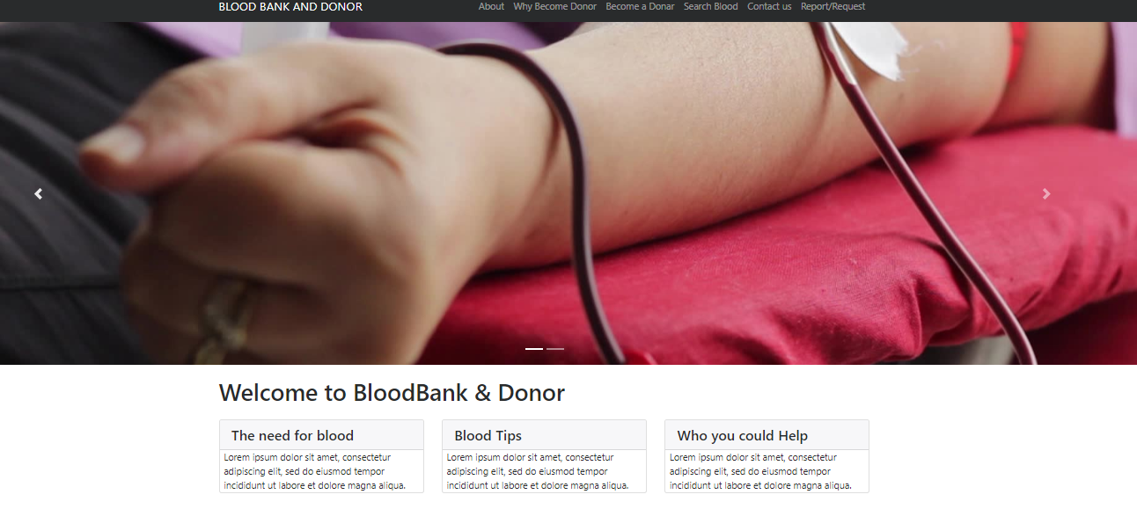
Figure 3 Homepage
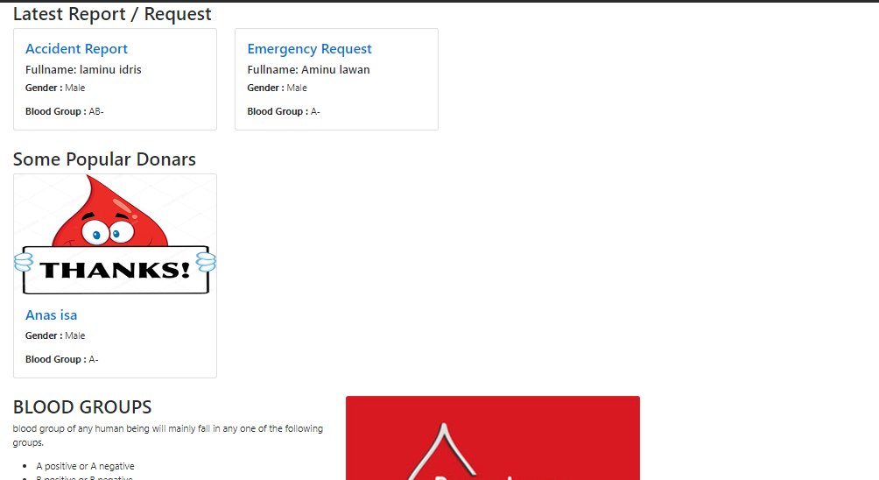
Figure 4 Latest Request
3.5 Testing Methods

I have used some essentials methods in Software testing techniques which are various methods or procedures used to evaluate the software to ensure that it works and is displayed as expected. But for other types of QA tests, only manual and automated tests come to mind. The following are the testing method I used.

Unit Testing
In this step to was able to test each and every stage of my project bit by bit to check if each modules or object classes are functioning as required. The functionality of objects or methods should be the main emphasis of unit testing. The below table is the process I used to test my software using unit testing.
Table 3.6 Unit Test Case
Test Case ID | Test Case Description | Preconditions | Test Input | Step | Expected Result | Actual Result | Status
TC-01 | Verify the field in the admin login screen | Admin login screen must exist | All field or username or password are blank and log in button is clicked | Click log in button | Warning messages: please fill out this field or cannot find account with the username or password | Warning messages to appeared if the all or one field are blank | Pass
TC-02 | Verify the field in the become a donor screen | become a donor screen must exist | All field are blank and save button is clicked | Click save button | Warning message: fill out this field | Please fill out this field | Pass
TC-03 | Verify the field in the request screen | request screen must exist | All description or maximum donor field are blank and save button is clicked | Click save button | Warning message: fill out this field | Please fill out this field | Pass

Integration Testing
In this stage I was able to test my software ability to check the links between components of one activity and another to ensure both it goes well. To see if the pages are integrated in a well and function way. The integration testing was carried out after the unit testing.
Table 3.7 Integration Test Case
Test Case ID | Test Case Objective | Test Case Description | Input | Expected Output | Result
TC-01 | Check the interface link between admin login module and the dashboard module | Click on the sign in link module | Sign in field clicked  Sign in field not clicked | To be directed to the dashboard module  Nothing happened | Pass  Pass
TC-02 | Check the interface link between homepage and the become a donor module | Click on the become a donor link module on the homepage module | the button is clicked | To directed to the become a donor module | Pass
TC-04 | Check the interface link between request/report module | Click on the add donor link module on the homepage module | Request/report button is clicked | To directed to the request/report module | Pass

CHAPTER FOUR
4.1 RESULT
The development of blood donor management software was archived using some methods and strategeis. these methods helps in creating the updated version software of blood donor management system. Here are some of the benefits and features of the new software which the software lacks
4.2 Comparisons between Existed Software and New Software
Table 4.1 Comparisons
Existing software | New software
The existed software is not effective in terms of logging and maintenance archived | The new software is more far better than old software in effectiveness and management
The old software is time consuming, it takes at least more than 30 seconds to load | The new software is designed to sped up time in less 2seconds
It also leads to prone and error | Prone and error process had been minimized
It lacks privacy of data and security | Its secures the privacy data of users
Retrieval of data takes more than enough time | Retrieval of data doesn’t takes more time to process
Percentage of accuracy is less | Accuracy percentage is high
It takes a lot of time to generate a report | The new software doesn’t take time to generates report
Its not user friendly | Its attractive and user friendly
At times it’s provide the security of page load without log in details. | It doesn’t
It doesn’t have any form of AI,ML | It has a voice search space for selecting a blood type

4.3 Recommendations

Every project that is completed has some suggestions that might be made for more study or software development; similarly, the following recommendations are taken into consideration for this method:

The program should be upgraded to include a visual aid for people who have vision impairments.

The system should have a mobile app created.
- The system should have a Fingerprint or Facial recognition for admin login page in other to secure user data.

CHAPTER FIVE

5.1 Summary
In summary, this project was the design and implementation of web-based software (blood donor system). This project automates a manual blood donation system and my implementation provides the following features: First of all, the accuracy of the data. Quick access to blood information. This system checks to see if administrators and users are authorized and allows only legitimate users to manage the system. Therefore, a blood donation system was proposed and developed for this project. The waterfall development model was selected for system development. The system consists of two modules, a visitor module and a management module. The visitor module allows users to become donors, search for blood, and post requests and complaints to the system. The Administrator module allows administrators to log in to the system and delete / validate donors. Requirements analysis for the blood donation system was performed using use case diagrams. Each module of the system and its features were described using use case diagrams. After all the requirements were analyzed, the system design was carried out. Once the system was designed, it was implemented. The implementation was done using Visual Studio Code (VS Code). Web pages were developed in HTML, which supports Javascript and Bootstrap as a client-side language. The PHP Framework was used as a server-side scripting language with the MySQL database management system Already used. The operating systems (OS) on which the system is running include Windows 7, Windows 8, Windows 10, and Mac OS. Then I tested it using a test case. The unit test case was developed to test each unit of the two modules. After all the bugs were fixed, I ran an integration test to check the interface connections between the modules and finally tested the whole system to make sure it met the requirements.
5.2 CONCLUSION

I have successfully developed a blood donation management system. Absolutely designed to replace manual systems associated with many issues such as blood test data misplaced, it provides an automated system to eliminate / mitigate the above issues. During the development of this method, most of the requests were met and, of course, the work on the system was done. In addition, the system can smoothly provide all features without development errors, all tests are run and the resulting errors are corrected successfully. We have made an effort to computerize numerous Blood Bank processes. Any branch of BLOOD BANK can utilize the Blood Bank Management System, which is very adaptable software, to store records. We have made an effort to include in this software all record-keeping features linked to the blood bank management system that are helpful in maintaining records of the people that work there. This project's primary goal is to require fewer human labor. The fact that all of the records are kept in the Mysql database makes record maintenance efficient. Compared to the current system, it is more user-interactive and efficient. The "BLOOD BANK MANAGEMENT SYSTEM" is more effectively maintained because to visual basic's flexibility. To enable future expansion, the system was designed to allow for possible changes and additional features.
Finally, we would want to express our gratitude to everyone who has helped us in this endeavor.

5.3 Future Enhancements

The system was created in the anticipated parameters, and it has proven to be successful and efficient. We should employ the techniques as much as we can. All technological advancements are fundamentally made for our benefit. Prototype layer has been used to test the system. Every alternative is viable, and that they all perform well. More changes to this program can be simply implemented because this technology is adaptable and flexible. The system can be readily installed in the office for the most effective operation.

Reference
Bani, M., Giussani, B.: Motivation in Italian whole blood donors and the role of commitment.
Psychol. Health Med. 16(6), 641–649 (2011)
Bani, M., Giussani, B.: Motivation in Italian whole blood donors and the role of commitment.
Psychol. Health Med. 16(6), 641–649 (2011)
Bani, M., Giussani, B.: Motivation in Italian whole blood donors and the role of commitment.
Psychol. Health Med. 16(6), 641–649 (2011)
Bani, M., Giussani, B.: Motivation in Italian whole blood donors and the role of commitment.
Psychol. Health Med. 16(6), 641–649 (2011)
Bani, M., Giussani, B.: Motivation in Italian whole blood donors and the role of commitment.
Psychol. Health Med. 16(6), 641–649 (2011)
Bani, M., Giussani, B.: Motivation in Italian whole blood donors and the role of commitment.Psychol. Health Med. 16(6), 641–649 (2011)
Belien, J., Forcé, H.: Supply chain management of blood products: a literature review. Eur. J. Oper.
Res. 217(1), 1–16 (2012
Belien, J., Forcé, H.: Supply chain management of blood products: a literature review. Eur. J. Oper.Res. 217(1), 1–16 (2012)
Blajchman, M.A., Shepherd, F.A., Perrault, R.A.: Clinical use of blood, blood components andblood products. Can. Med. Assoc. J. 121(1), 33–42 (1979)
Chau, M., Cheng, E. Chan, C.W.: Data analysis for healthcare: a case study in blood donation centeranalysis. In: Proceedings of 16th Americas Conference on Information Systems AMCIS, p. 242(2010)
Council of Europe: Guide to the Preparation, Use and Quality Assurance of Blood Components,
ISBN: 9789287161376 (2007)
Council of Europe: Guide to the Preparation, Use and Quality Assurance of Blood Components,ISBN: 9789287161376 (2007)
De Angelis, V., Felici, G., Impelluso, P.: Integrating simulation optimisation in health care centremanagement. Eur. J. Oper. Res. 150(1), 101–114 (2003)
Ekici, A., Ozener, O.O.: Routing for blood supply management. In: 20th Conference of theInternational Federation of Operational Research Societies IFORS (2014)
Ghandforoush, P., Sen, T.K.: A DSS to manage platelet production supply chain for regional bloodcenters. Decis. Support Syst. 50(1), 32–42 (2010)
Hirsch, R.L., Cazal, P.: Recommendations of the task force on record-keeping and blooddistribution systems. Vox Sang. 40(3), 216–221 (1981
Kendall, K.E., Lee, S.M.: Formulating blood rotation policies with multiple objectives. Manag.
Sci. 26(11), 1145–1157 (1980)
Le, T., Diabat, A., Richard, J. P., Yih, Y.: A column generation-based heuristic algorithm for an
inventory routing problem with perishable goods. Optim. Lett. 7(7), 1481–1502 (2013)
McKeever, T., Sweeney, M.R., Staines, A.: An investigation of the impact of prolonged waiting
times on blood donors in Ireland. Vox Sang. 90(2), 113–118 (2006)
McCullough, J.: Transfusion Medicine, 2nd edn. Churchill Livingstone, London (2005)
Michaels, J.D., Brennan, J.E., Golden, B.L.: A simulation study of donor scheduling systems for
the American Red Cross. Comput. Oper. Res. 20(2), 199–213 (1993)
Ofori, S.O., Temple, J., Sarkodie, F.: Predonation screening of blood donors with rapid test.
Transfusion 45(2), 133–140 (2005)
Prastacos, G.P., Brodheim, E.: PBDS: a decision support system for regional blood management.
Manag. Sci. 26(5), 451–463 (1980)
Prastacos, G.P., Brodheim, E.: PBDS: a decision support system for regional blood management.Manag. Sci. 26(5), 451–463 (1980)
Schereiber, G.B., Glynn, S.A., Damesyn, M.A., et al.: Lapsed donors: an untapped resource.
Transfusion 43(1), 17–24 (2003)
Shen, Z., Coullard, C., Daskin, M.: A joint location-inventory model. Transp. Sci. 37(1), 40–55
(2003)
Yi, J.: Vehicle routing with time windows and time-dependent rewards: a problem from the
American Red Cross. Manuf. Serv. Oper. Manag. 5(1), 74–77 (2003).

APPENDIX
Appendix 1 INDEX.PHP
Dashboard Page
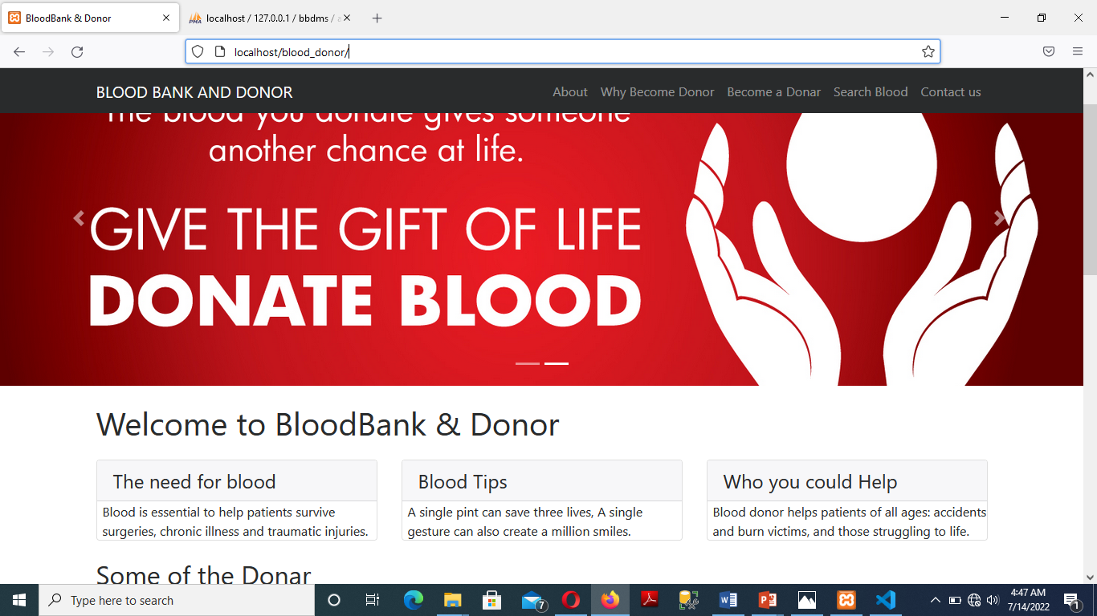
Appendix 2 INDEX.PHP Login Page Admin
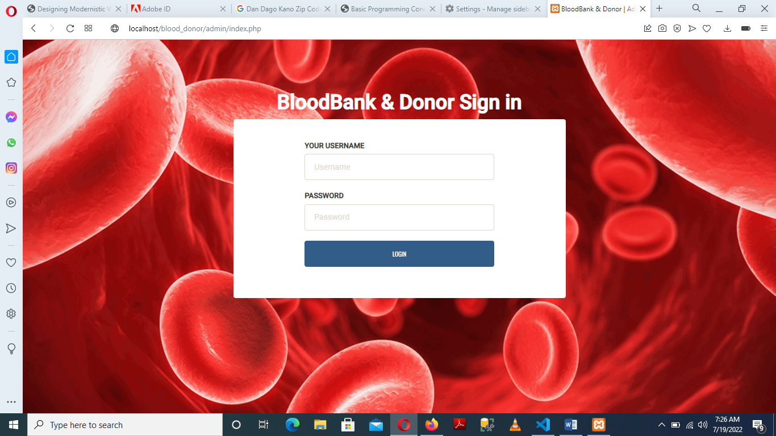
Appendix 3 INDEX.PHP Become A Donor Page
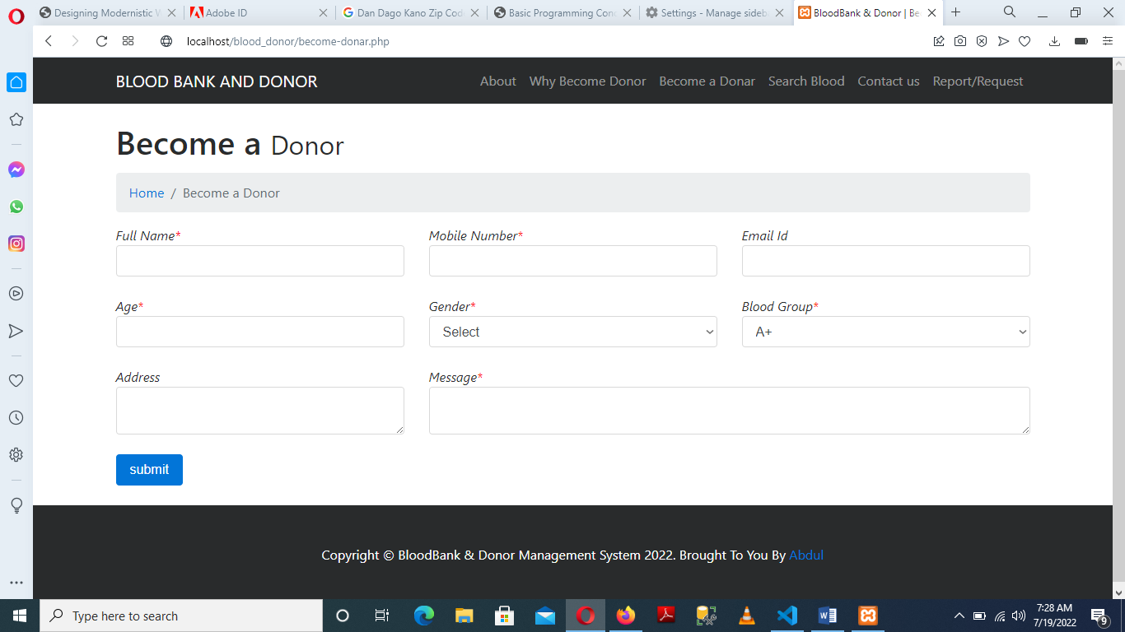

Appendix 4 INDEX.PHP Report/Request Blood
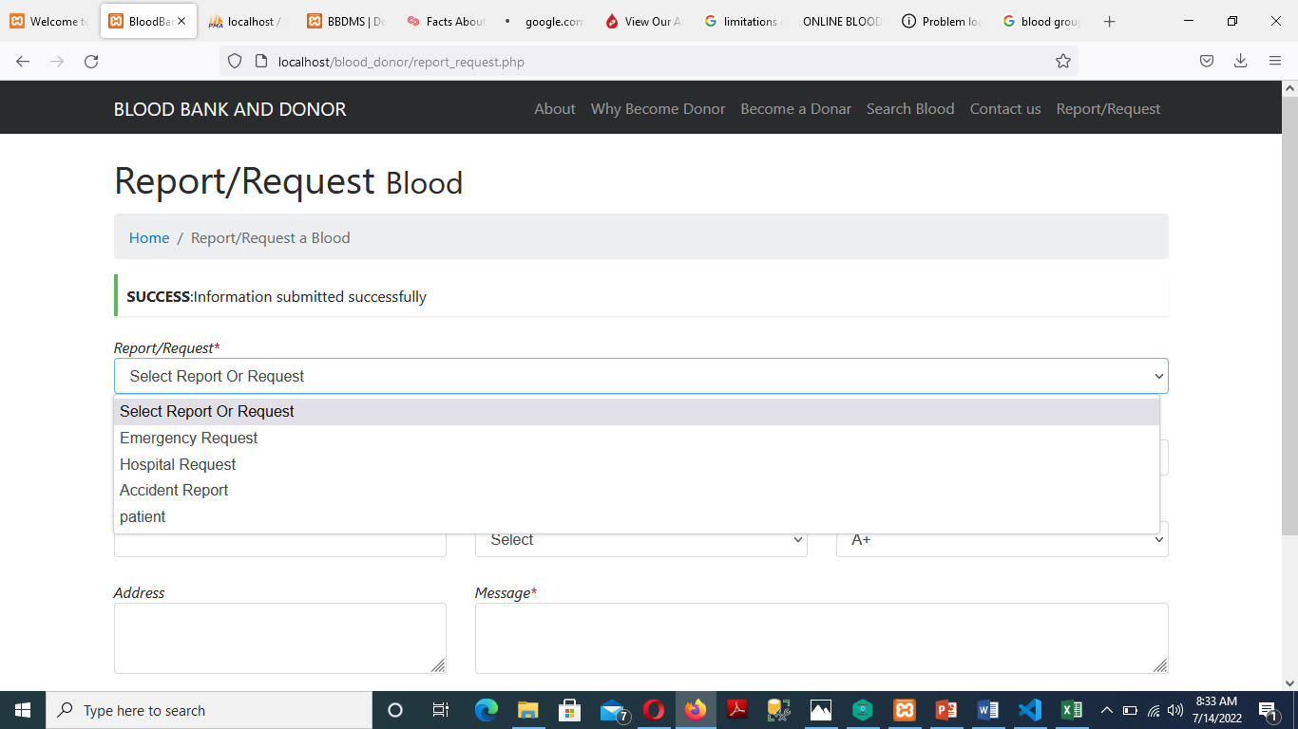
Appendix 5 INDEX.PHP Contact Us
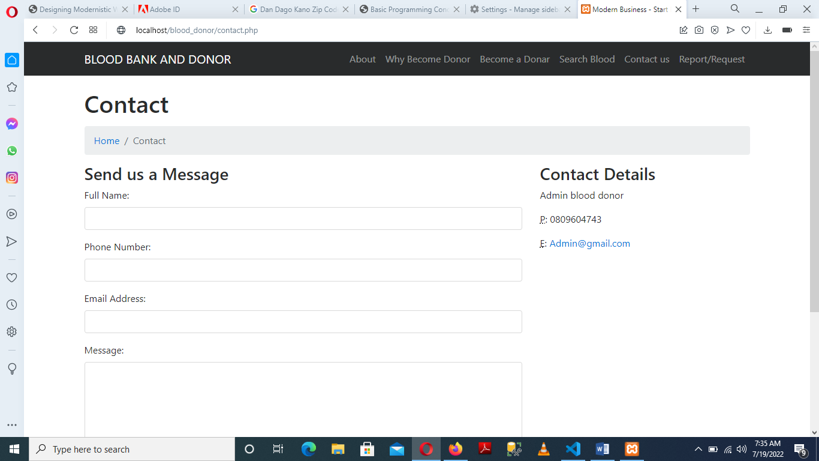
Appendix 6 INDEX.PHP About Us
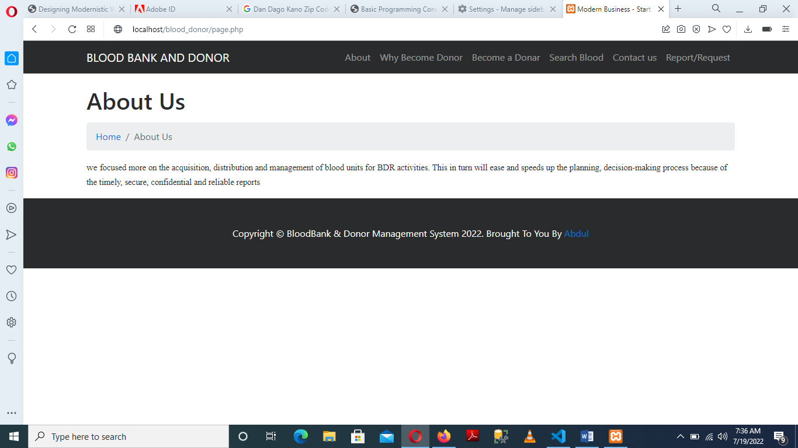
Appendix 7 INDEX.PHP Admin Dashboard
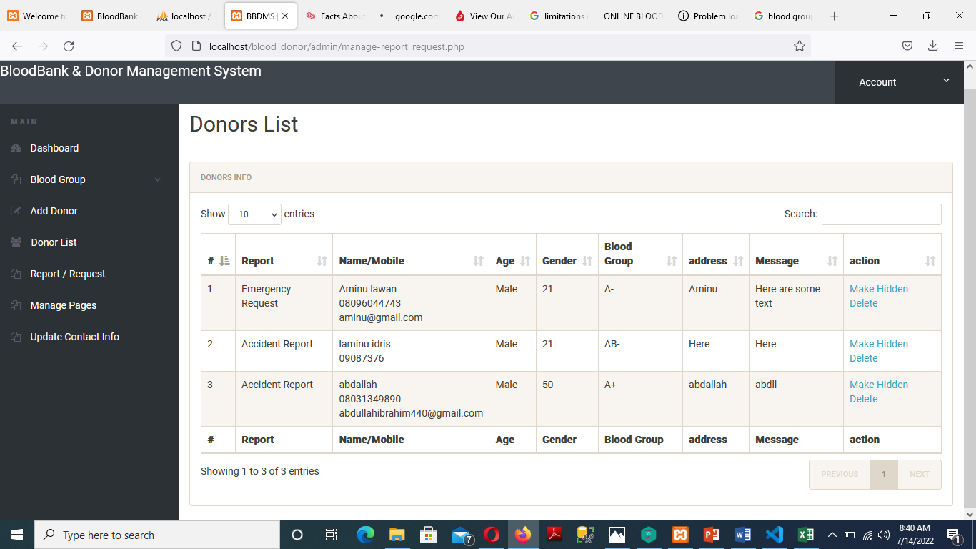
Appendix 8 INDEX.PHP Database
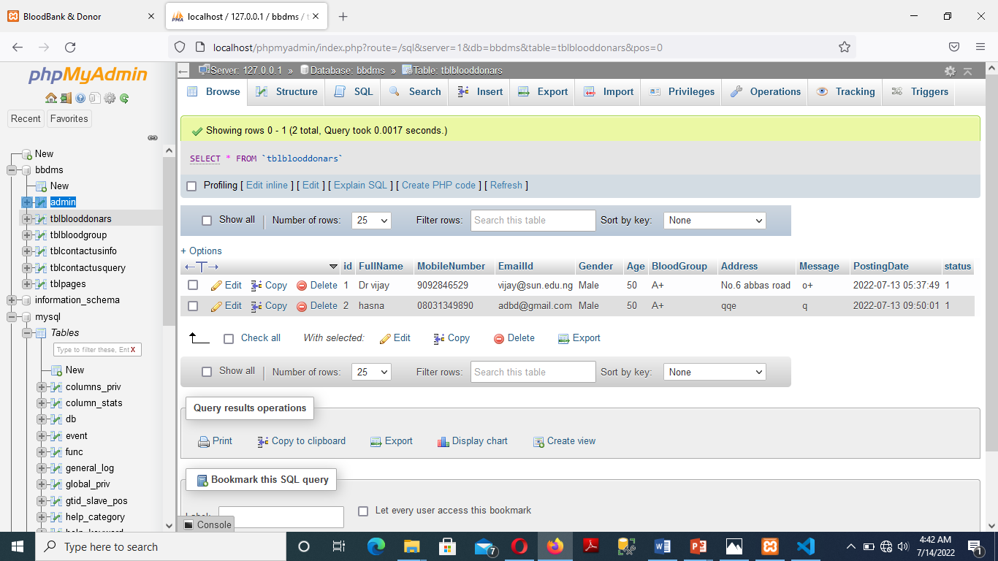
Appendix 9 INDEX.PHP Database
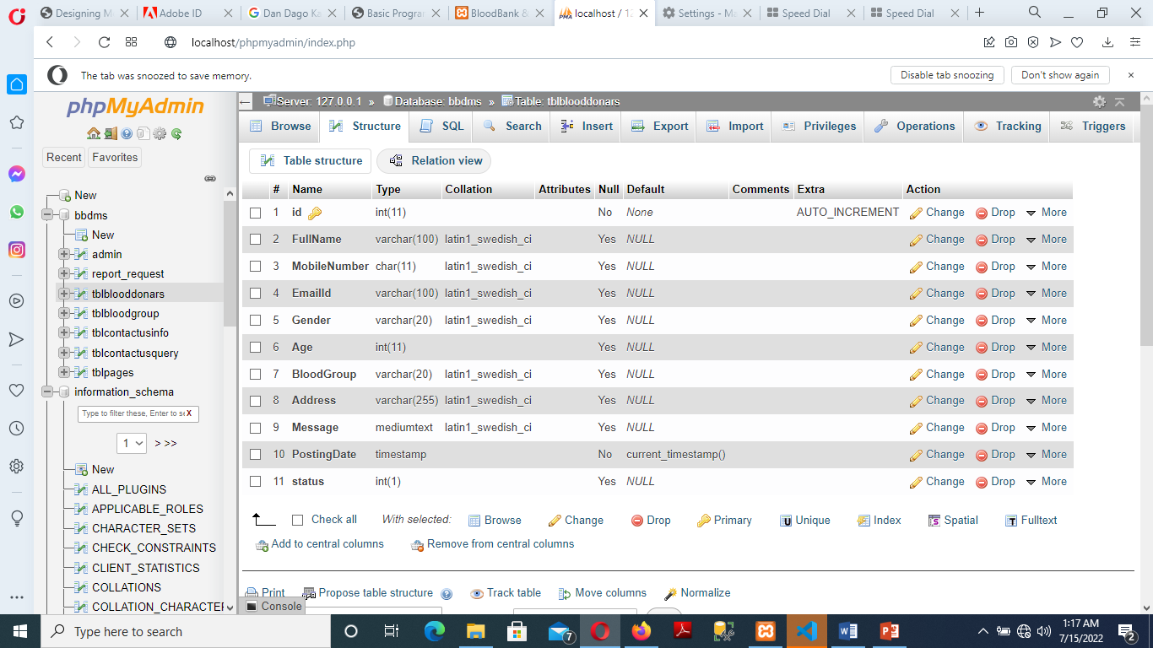
Appendix 20 INDEX.PHP Sample Coding
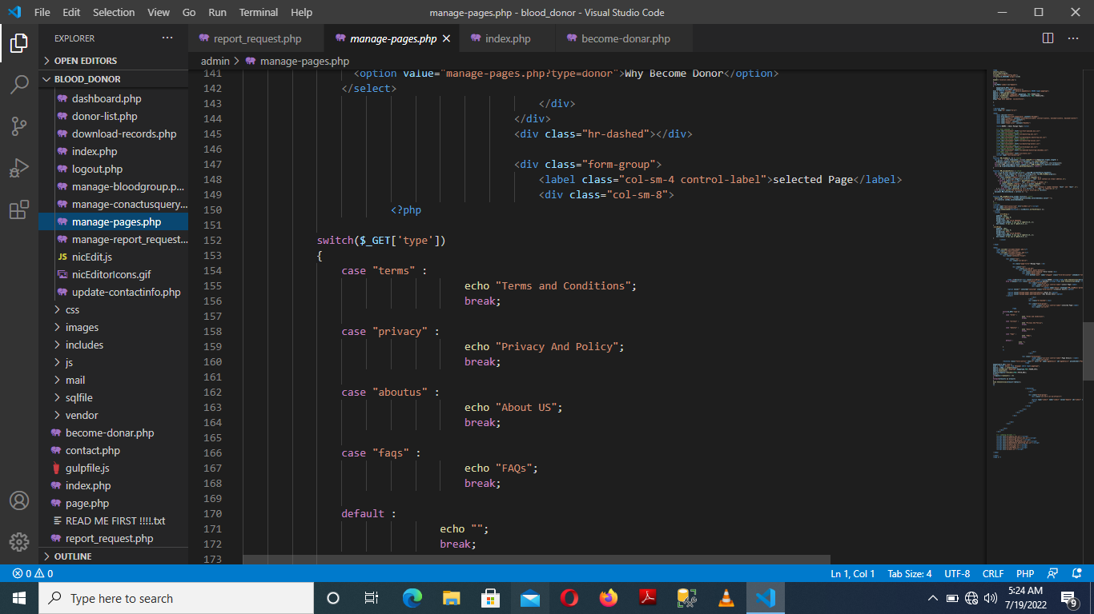
Appendix 31 INDEX.PHP Sample Coding
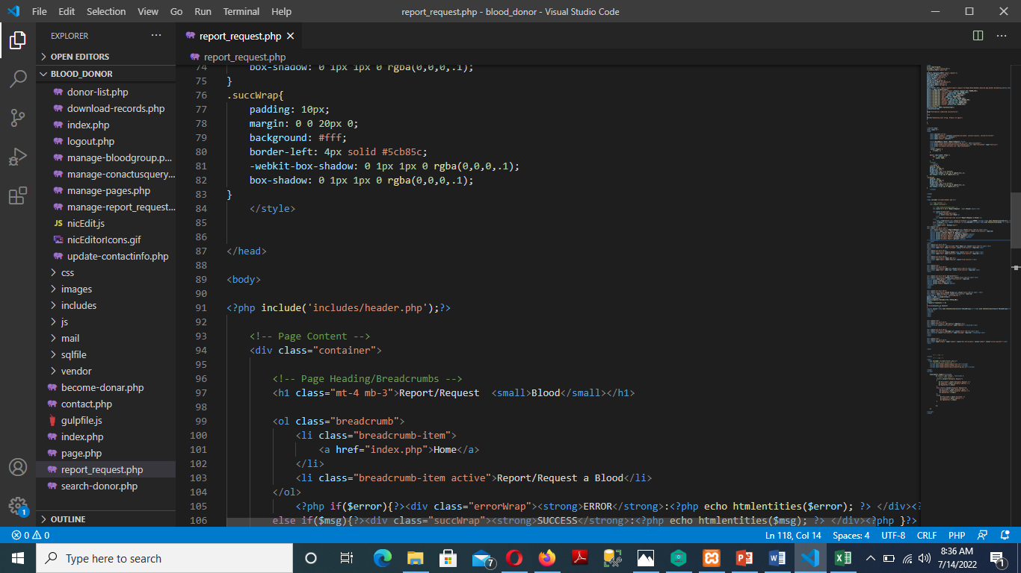
Appendix 42 INDEX.PHP sample coding
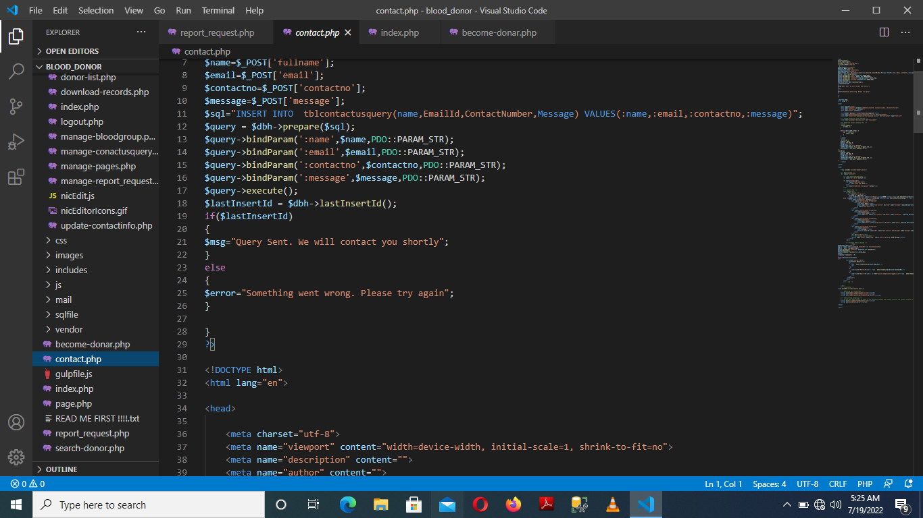
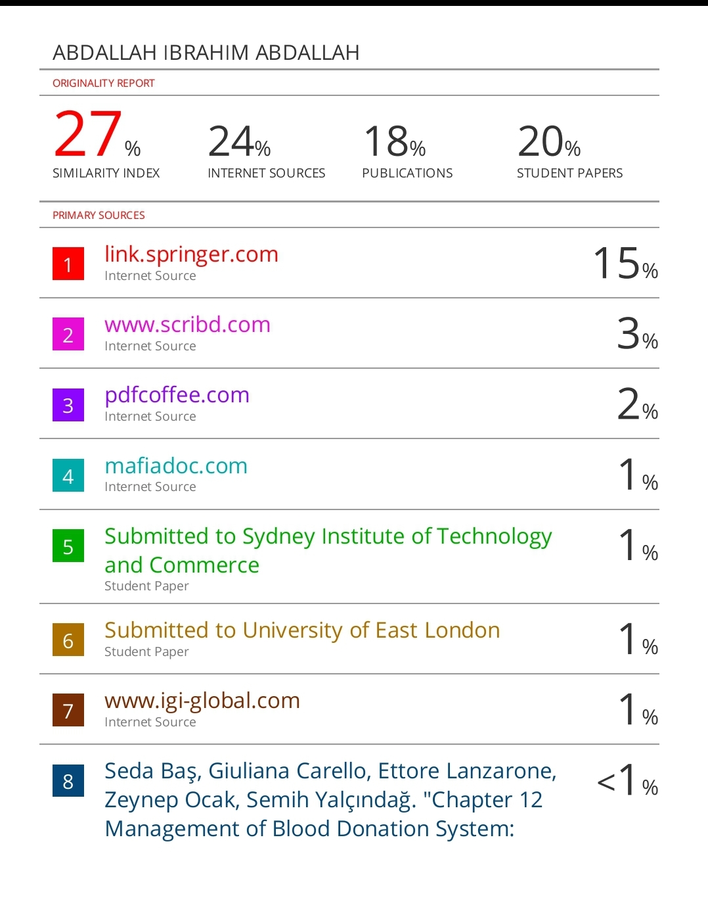

Work plan
OBJECTIVES | TIME FRAME
Requirement gathering | 2 weeks
Requirement Analysis | 1 week
Implementation | 1 month
Development | 1 month
Testing | 3 weeks

