**WEB BASED STUDENT INFORMATION MANAGEMENT SYSTEM FOR SKYLINE UNIVERSITY NIGERIA**

**A project report Submitted to the Skyline University, Nigeria**

In Partial fulfilment for the award of Degree of

**BACHELOR OF SCIENCE IN COMPUTER SCIENCE & INFORMATION SYSTEMS**

**PROJECT REPORT**

***Submitted by***

**NAZIR SAFIYAN SALISIU**

**(ID: 1082)**

***Under the Guidance of***

**Dr.A.SENTHIL KUMAR MCA, M.Phil. MBA, ME., Ph.D.,**

**Dean-SSIT**

**Department of Computer Science & Information Systems**



**DEPARTMENT OF COMPUTER SCIENCE & INFORMATION SYSTEMS**

**SKYLINE UNIVERSITY, NIGERIA**

**JULY 2022**

# CERTIFICATE

This is to certify that the project work entitled **“WEB BASED STUDENT INFORMATION MANAGEMENT SYSTEM FOR SKYLINE UNIVERSITY NIGERIA”** is a benefited record of project work done by **NAZIR SAFIYAN SALIS (ID NO: 1082),** submitted to Skyline University, Nigeria in partial fulfilment of the requirement for the award of the Degree of **Bachelor of Science in Computer Science and Information Systems.**

**Signature of the Guide Signature of the HOD**

**Dr.A.SENTHIL KUMAR DR.VIJAY ARPUTHARAJ** Dean-SSIT Head of the Department

Submitted for the University Project Viva-voce held on____________

**INTERNAL EXAMINER EXTERNAL EXAMINER**

# DECLARATION

I **NAZIR SAFIYANU SALISU (1082)** hereby declare that the project work entitled **“WEB BASED STUDENT INFORMATION MANAGEMENT SYSTEM FOR SKYLINE UNIVERSITY”** submitted to the Skyline University, Nigeria in partial fulfilment of the requirements for the award of the Degree of Bachelor of Science in Computer Science and Information systems is a record of original work done by me during 2021-2022 under the supervision and guidance of **Dr.A.SENTHIL KUMAR MCA.,M.Phil.,MBA.,ME.,Ph.D.,** Dean,SSIT, and that it has not formed the basis for the award of any Degree or other similar title to any candidate of any University.

**Signature of the Candidate**

**Place :**

**Date :**

# ACKNOWLEDGEMENT

I hereby acknowledge and wish to register my profound gratitude to Almighty ALLAH for the guardian and grace throughout my life and to the days of my program.

I am grateful to the **Vice Chancellor, Registrar** of Skyline University, Nigeria for all the supports and efforts in making my years of program interesting, educative and worthwhile to be proud of.

I wish to extend my sincere thanks to our **HOD Dr. VIJAY ARPUTHARAJ**, and the rest of my lecturers, lab assistance for their seasoned lectures, motivations and all the supports, may Almighty ALLAH Reward you all in another format of his blessings.

My special gratitude goes to my supervisor **Dr.A.SENTHILKUMAR MCA.,M.Phil.,MBA.,ME.,Ph.D**, **Dean-SSIT**, without whose motivation and guidance I would have not able to remark on a project of this magnitude.

My affectionate regards goes to my amazing parents who financially, supportive and in any of the other ways supported my educational pursuit to see me flourishing to the higher purpose, I appreciate you all to the fullest, May **Almighty Allah** bless you abundantly.

I wish to thank all hand and minds that helped me, all my friends and well-wishers who are all behind the success of my project.

**NAZIR SAFIYAN SALIS**

# ABSTRACT

Student Information Management System (SIMS) is a system software that provides a user friendly interface for maintenance of student information. It is aimed to be used at educational sectors like higher institutions and colleges to easily maintain the records of students. The management and creation of accurate, up-to-date and precise information regarding a students’ academic career is critically important in the university as well as colleges. The student information system deals with all kind of student details, academic related reports, college details, course details, curriculum, batch details, placement details and other resource related details too. It tracks down all the details of a student from the day one to the end of his/her course which can be used for all reporting purpose, tracking of attendance, progress in the course, completed semesters, years, coming semester year curriculum details, exam details, project or any other assignment details, final exam result and all these will be available through a secure, online interface embedded in the college’s website. It will also have faculty details, batch execution details, students’ details in all aspects, the various academic notifications to the staff and students updated by the college administration. It also facilitate us to explore all the activities happening in the college. Mainly, the Student information system software focused on integrating advanced security features using (AI).

**Table of Contents**

CERTIFICATE i

DECLARATION ii

ACKNOWLEDGEMENT iii

ABSTRACT iv

LIST OF FIGURES vii

LIST OF ABBREVIATIONS viii

**CHAPTER 1** 1

INTRODUCTION 1

1.1 OVERVIEW OF THE PROJECT 1

1.1.1 Aim & Objectives 2

AIM OF THE STUDY 2

OBJECTIVES OF THE STUDY 2

1.1.2 Motivation 2

1.2 SYSTEM SPECIFICATION 2

1.2.1 Hardware Specification 2

1.2.2 Software Specification 3

1.3 SOFTWARE DESCRIPTION 3

1.3.1 about HTML 3

1.4 WAMPP 5

1.5 MySQL 6

A. How Does MySQL Work? 7

Figure no.: 1.1 7

1.5.1 Features 8

**CHAPTER 2** 9

LITERATURE REVIEW 9

2.2 PROPOSED SYSTEM 16

2.2.1 Benefits of Proposed System 16

**CHAPTER 3** 17

SYSTEM ANALYSIS AND DESIGN 17

3.1 INTRODUCTION 17

3.2 SOFTWARE DEVELOPMENT LIFE CYCLE (SDLC) 17

3.2.1 CHOSEN MODEL 17

3.3 WATERFALL MODEL 17

Figure 3.1: Waterfall Model (www.tutorialpoint.com, 2017) 18

3.3.1 DESCRIPTION OF THE SYSTEM 18

3.4 REQUIREMENT DEFINATION 18

3.4.1 Functional requirements 19

3.4.2 Non-Functional Requirements 19

3.5 REQUIREMENTS ANALYSIS 19

Figure 3.2: Use Cases Diagram for the proposed student information system 20

3.6 DATABASE DESIGN 21

TABLE 3.1: LOGIN TABLE 22

TABLE 3.2 REGISTERATION TABLE 22

**CHAPTER 4** 23

4.1 OBJECTIVE OF TETSING 23

4.2 TESTING METHODS 25

4.2.1 Unit Testing 25

4.2.2 Black Box Testing 26

4.2.3 White Box Testing 26

4.2.4 Integration Testing 26

4.2.5 Output Testing 26

4.3 IMPLEMENTATION 26

4.4 TEST CASE REPORT 27

**CHAPTER 5 29**

5.1 CONCLUSION 29

5.2 SCOPE FOR FUTURE DEVELOPMENT 29

References 30

APPENDICES 31

APPENDIX-1 SAMPLE SOURCE CODE 31

LOGIN PAGE 31

# 

# LIST OF FIGURES

|  |  |  |
| --- | --- | --- |
| **FIGURE NUMBER** | **NAME OF THE FIGURE** | **PAGE NUMBER** |
| 1.1 | (How MySQL Works) | 7 |
| 3.1 | Waterfall Model | 20 |
| 3.2 | Use Cases Diagram for the proposed student information system | 22 |
| A 2.1 | ADMIN LOGIN PAGE | 39 |
| A 2.2 | ADMIN HOME PAGE | 39 |
| A 2.3 | ADMIN NOTICE BOARD | 40 |
| A 2.4 | ADMIN STAFFS TABLE | 40 |
| A 2.5 | STUDENT LOGIN PAGE | 41 |
| A 2.6 | STUDENTS HOME PAGE | 41 |
| A 2.7 | STUDENTS SUGGESTION BOX | 42 |
| A 2.8 | STUDENTS STAFF VIEW | 42 |

**LIST OF TABLES**

|  |  |  |
| --- | --- | --- |
| **TABLE NUMBER** | **NAME OF THE TABLE** | **PAGE NO** |
| 2.1 | LITERATURE JOURNALS | 11 |
| 3.1 | LOGIN | 18 |
| 3.2 | REGISTERATION TABLE | 19 |
| 3.3 | COURSE TABLE | 19 |

# 

# LIST OF ABBREVIATIONS

|  |  |  |
| --- | --- | --- |
| **NAME OF ABBREVIATION** | **FULL FORM** | **PAGE NO** |
| SIMS | Student Information Management System | 13 |
| HTML | Hypertext Mark Up Language | 4 |
| CSS | Cascading Style Sheet | 5 |
| SQL | Structure Query Language | 7 |
| DB | Data Base | 7 |

# CHAPTER 1

# INTRODUCTION

## OVERVIEW OF THE PROJECT

We are living in an era of extraordinary change and working towards the information age. Directors need to adapt to large amounts of information, transform that information into data, make decisions about that data, and make decisions that lead to the achievement of business goals.

When we surf the internet every day, we visit many websites. Some are complex and some are simple personal pages. The term "website" refers to a summary of all content published online. Each file is part of what the website represents. And the driving force behind a website, the pillar that puts it together, is a web page.

Biometrics is a measure of a biological quantity or pattern, but it also means measuring a person's characteristics, such as a fingerprint, that can identify or authenticate a person.

A biometric is a password that cannot be stolen, lost or forgotten.

The information management system is a software for students that handles almost all kind of student details, university details, academic reports, course details, syllabuses, batch details, and other resource-related details. Track all student details from the first day to the end of the course. This is required for report objectives, attendance tracking, course progress, and year of completed semester, syllabus details for the next semester, exam details, project, or other task details. , Final test results; all of these will be available for future reference.

## 1.1.1 Aim & Objectives

# Aim

To design and implement an Information Management System for storing students’ records.

# Objectives

1) To provide an organized system of information management.  
2) To help in monitoring and accountability for future planning.  
3) To assist lecturers in making some instructional decisions and also to obtain specific information that may help in working with a student.  
4) To help in evaluating the success of most programs in a curriculum.

# 1.1.2 Motivation

Unavailability of student’s information management systems in various institutions. This issue has been resulting in many institutions making improper decision making in other to implement on needed changes.

To design and implement web based student information systems with the intent to improve upon the existing manual of student guidelines (Student Hand Book) and to develop a web based application that will majorly help in generating students information as well as disseminating information to the students.

# 1.2 SYSTEM SPECIFICATION

The performance specifications of a system, like a computer, are described in a system specification. It is regarded as a high-level document that specifies universal operations.

# 1.2.1 The Hardware-Requirements

Processor : Intel(R) Core(TM) 2 Duo

Hard disk : 8GB (minimum)

Memory : 3GB RAM

Speed : 2.33 GHZ

Key-board : Windows standard keyboard

Mouse : Two or Three button mouse

# 1.2.2 Software-Requirements

Operating system : Windows 7

Coding language : HTML

Data base : MYSQL

Server : XAMPP

Web technologies : HTML, CSS.

# 1.3 SOFTWARE DESCRIPTION

# 1.3.1 Hyper Text Mark-up Language

Hypertext **Markup** Language (HTML) is a **markup** language that is used for documents designed to be **displayed** in a web browser. It can also be **supported** by technologies like cascading **style sheets** (CSS) and scripting languages **like** JavaScript.

Hypertext mark-up language documents are downloaded by a web browser from a web server or local storage and converted into multimedia web pages. The HTML originally contains information about the appearance of the document and semantically explains the structure of the website. HTML pages are made up of HTML elements. HTML can contain scripts written in languages ​​such as JavaScript that can change the behaviour and content of web pages. Including CSS makes it clear how the information is displayed and organized. Since 1997, the World Wide Web Consortium (W3C), the organization that oversees the development of HTML and CSS, has advocated the use of CSS over HTML for explicit presentations.

B. So-called tags (and their attributes), character-based data types, character references, and entity references are part of the main part of HTML mark-up. The most common way to send HTML tags is in pairs. B. But some of them represent empty components, so for example they are not paired. The "start tag" and "end tag" tag pairs help show the range of components in simple and common scenarios. If the element has text content, they are included between these tags. Allows additional mark-up, such as text and other tags, between the beginning and end of the tag. As a result, additional (nested) elements appear as children of the parent element. Since its inception, HTML has improved dramatically.

HTML5 also introduced some semantic improvements. The new semantic tag tells the browser what the content means. This benefits both readers and search engines.

# 1.4 WAMPP SERVER

WampServer is also used in the Microsoft Windows operating system solution stack that was developed by Romaine Bourdon, which consists of an Apache web server, OpenSSL for SSL support, a MySQL database, and a PHP programming language.

**Some Notable lists and equivalents on other platforms are:**

* LAMP: stands for Linux as an operating system.
* MAMP: stands for the operating system of Mac computers
* SAMP: Solaris operating system is referred to as SAMP.
* WIMP: A comparable software called WIMP uses Internet Information Services as place of Apache (IIS)
* WISA: This is the Windows (operating system) solution stack, which includes ASP.NET, Microsoft SQL Server, and Internet Information Services.
* XAMPP: This is a stack of cross-platform software for web servers.

**WAMP**: Windows, Apache, MySQL, and PHP are collectively referred to as WAMP. This is a stack of software. Therefore, when WAMP is installed on Windows, Apache, MySQL, and PHP are also installed. It can be installed separately, but it is usually bundled for good reason. It's good to know that WAMP is the predecessor of LAMP (L stands for Linux). The only difference between the two is the use of WAMP for Windows and LAMP for Linux-based operating systems.

Let’s quickly go over what each letter represents:

1. **“W”:** The letters "W" represent for Windows, LAMP (for Linux), and MAMP (for Mac).
2. “**A**”**:** Apache is the meaning of "A." The server program in charge of delivering web pages is called Apache.
3. “**M**”**:** MySQL is denoted by "M." Your server's database management system is called MySQL. It keeps track of all pertinent data, including user profiles and website content.
4. “**P**”**:** PHP is represented by "P." It is the programming language that was employed in the creation of Word Press.

**WAMP streamlines the development and theme design processes. Additionally, you have the benefit of modifying your website to your heart's delight.**

# 1.5 MySQL

RDBMS, or relational database management system, MySQL is open source. The name is made up of "My," the name of co-founder Michael Widenius's daughter, and "SQL," which stands for "Structured Query Language." The GNU General Public License and numerous ownership agreements are the legal frameworks under which the MySQL Development Project has made its source code accessible. A single for-profit Swedish corporation, MySQL AB, which is now owned by Oracle Corporation, is the owner and sponsor of MySQL. The premium serial edition is distinct and offers extra features.

One of the most well-known RDBMS programs that uses the client-server architecture is MySQL. In an RDBMS context, how do clients and servers communicate? Use the domain-specific language SQL, or structured query language. Any other name that contains SQL should be avoided. The syntax of structured query language may also be used by other platforms, including PostgreSQL and Microsoft SQL Server. Although other programming languages are sometimes used to create RDBMS applications, SQL is always the primary language for communicating with the database.

## How Does MySQL Work?

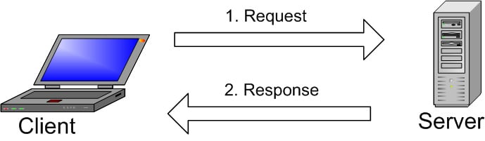

# Figure no.: 1.1 (MySQL Client-Server)

The client-server structure's fundamental components are depicted in the image. A specific network is used by one or more devices (clients) to connect to the server. The server fulfills requests from all clients using the on-screen graphical user interface (GUI), provided that both parties comprehend the instructions. Without getting too technical, the primary procedure that occurs in a MySQL system is the same.

1. MySQL constructs a database in order to store and manipulate data as well as to establish the connections between each table.
2. To run a query, the client can enter a specific SQL statement into MySQL.
3. In response, the server program provides the required data and displays it on the client side.

This is almost complete. Customers often emphasize the best MySQL GUI to use. Data management tasks are faster and easier because the GUI is lighter and more user-friendly. The most commonly used MySQL GUIs include Navicat DBAdmin Tool, SequelPro, MySQL Workbench, and DB Visualizer. Some of them only work on macOS, but they are compatible with other popular operating systems. Some are free and some are paid. Customers need to choose a GUI based on their needs. The easiest place to manage a web database, including your Word Press site, is PhpMyAdmin.

# 1.5.1 Features

MySQL comes in two editions: an open source community server and a private enterprise server. MySQL Enterprise Server extensions are unique and installed as server plugins, but they all use the same code base and follow the same numbering scheme.

Major features as available in MySQL 5.6:

* A significant portion of ANSI SQL 99 and its expansions
* A Cross-platform support
* A few stored procedures that strictly follow SQL/procedural PSM's language
* The Setoffs
* An error
* Viewable updates
* When using the InnoDB Storage Engine, an Online Data Definition Language (DDL).
* The information model

# CHAPTER 2

# LITERATURE REVIEW

2018 (JENNIFER) This system provides an effective and efficient academic information system. Clearly documenting student and employee information greatly improves timely support for decision making. This technology has also greatly helped raise awareness of the information age of various institutions and companies, breaking down the unsightly skeleton of reliance on manual and older systems. This makes it easier to code, build, and host database-driven websites according to specific rules and regulations. In addition, it accelerates information processing and sports feedback, giving new database developers a foothold. Researchers can also discuss the tools needed to design and implement functional Internet information service servers and HTTP web servers, and encourage higher education institutions to focus on the possibilities achieved with the latest communication methods.

Ercan (2010) evaluated the educational benefits of online computing infrastructure, especially in environments where computers are more commonly used. To better support business priorities as business demand grows, responsible IT professionals need to find creative ways to reallocate limited internal resources. In addition to improving internal functionality and improving service to customers, strategic partners and end users, this leads to greater reliance on third-party services (Ercan, 2010). Researchers introduce web computing to educators so they can better understand the concepts of online technology and their impact on education and classroom learning. The subject of this survey is only the use of cloud services in educational institutions. This limits the possible use of research and may lead to new research needs.

Chaowei and Manzhu (2016), using web computing to tackle big data challenges to be able to convert the four V’s. (volume, speed, precision, diversity) of big data to the fifth (value) Find out how to deal with it. It was conducted. This white paper introduces web computing as a new paradigm for providing computing as a utility service that meets a variety of processing needs. Researchers' research focus is solely on big data challenges.

Jouini and Ben Arfa Rabai (2016), review the latest cyber security risk assessment technologies for web computing systems. Information security risk assessment is considered difficult and costly. To achieve secure corporate information, the metrics used to evaluate security systems within the organization needed to be improved (Jouini & Ben Arfa Rabai, 2016). Many information security assessment models have been published, studied and compared by researchers. The resulting comparison allows decision makers to choose the best model for assessing the security risks of their web computing environment and other information systems (Jouini & Ben Arfa Rabai, 2016). The survey included only five information security assessment models.

Azarm-Daigle, Kuziemsky and Peyton (2015), presented a systematic literature review of Cross-organizational healthcare data sharing. Patient privacy had made Healthcare professionals have hesitated to commit to real-time data sharing between organizations due to patient privacy concerns. For interoperable healthcare organizations, exchanging health data between organizations is an important issue (Azarm-Daigle, Kuziemsky & Peyton, 2015). This treatise is a review that only considers sharing of health data. Therefore, future work needs to consider other regions.

Jayant and Bhise (2016), studied internet of things (IoT) data and propose a cloud system that allow organizations to store their data. Data is stored with the third party cloud provider therefore the user does not have knowledge where the data is stored and not have control over it (Jayant & Bhise, 2016). They proposed theses issue can be solved by insuring secure Data Transfer. The study was limited to internet of things data (IoT) only, there for further research on other variety of data is needed.

Khadija, Michel, and Hamid (2016) conducted Survey on Smart Mobile Device (SMD) Limitations, Including: B. Battery life, processing power, and storage capacity limitations are one of the problems with mobile cloud computing (MCC). This white paper described computational offload as an alternative to overcoming the limitations of these smart mobile devices (SMDs). Researchers cite the shortcomings of the MCC domain outsourcing framework, which requires additional research to consider alternate options.

Syed Asad, Mehwish, Atif, and Imran (2017) explored multiple cloud and web services at different layers to identify attack types and risk levels. Consider the risk intensity levels associated with data encryption, multi-tenancy, and privacy, authentication, and security requirements for various cloud and web services. In addition, it provided a multi-level classification of threats related to security attacks against various cloud services. This essay outlines the security concerns of a single cloud service. The entire cloud system needs to be investigated more closely.

**Table No: 2.1 Literature Review**

|  |  |  |  |  |  |  |  |  |
| --- | --- | --- | --- | --- | --- | --- | --- | --- |
| **S/N** | **Ref. No** | **Year** | **Paper type** | **Objective(s) of the research** | **Research Problems/issues** | **Solution** | **Limitation** | **Tool/Model** |
| 1 | 2 (2010) 938–942 | 2010 | Journal paper | To check out what web design does in education, especially in universities where computer usage is more intense. | Raise in business demands forces Responsible IT professionals need to innovate and reallocate limited internal resources to better support business priorities as business needs evolve. We rely heavily on third-party services to improve internal functionality and better meet the needs of our customers, key partners, and end users. | 1. This paper introduces educators to web design computing and helps them better understand the concepts of web design technology and its impact on education and learning in educational institutions. | The researcher only focuses on the usage of design service in educational institutions, which narrow down research scope and the need for further exploration and research may arise. | NILL |
| 2 | 61 (2017) 120-128 | 2016 | Article | To investigate on how web design Computing can be used to address Big Data challenges and to enable the transformation of Big Data's 4 V’s (volume, velocity, veracity and variety) into the fifth (value) | 1. How to address the diversity and credibility of big data to create merged datasets that can be used in a single decision support system.  2. How to deal with the velocity of big data to achieve scalable and scalable processing power based on fluctuations in the data feed. | The paper introduces web design Computing as a new paradigm to provide computing as a utility service for  addressing different processing needs | The researcher’s investigation focuses on how web computing can be used to address Big Data challenges only. | NILL |
| 3 | 83 ( 2016 ) 1084 – 1089 | 2016 | Symposium  Paper | A state-of-the-art overview of cyber security risk assessment for web design systems. Review of existing models for purpose and subsequent analysis. The stage of risk management mentioned. The main risk management concepts covered. And the source of stochastic data. | Information security risk assessment is considered difficult and costly. The pursuit of secure corporate information has created a need for development Better metrics to understand your organization's security behaviour. | Researchers presented and analysed several information security assessment models and compared each presented model. The resulting comparisons help decision makers choose the right security risk assessment model for their web design environment and other information systems. | The research was limited only five information security assessment models. | NILL |
| 4 | 63 ( 2015 ) 425 – 432 | 2015 | Journal paper | To present a systematic literature study on the exchange of health data between organizations on the Internet. | Healthcare stakeholders had been hesitant to commit to real-time, cross-organizational data exchange due to concerns about patient privacy.  In interoperable healthcare organizations, sharing healthcare data between organizations is a significant problem. | Researchers have derived the following criteria for interoperable HIS: To what extent are end-user requirements met? The reporting ability of the system; cost efficiency; flexibility to adapt to future changes in clinical processes. | The paper is review paper that considered only healthcare data sharing. Therefore other areas need to be considered in future work. | NILL |
| 5 | 89 ( 2016 ) 43 – 50 | 2016 | Journal paper | To study internet of things (IoT) data and propose a web based system that allow organizations to store the data | 1. The user does not know where the data is stored and has no control over it because the data is stored with a third-party cloud provider. 2. Concerns with maintaining the accuracy and integrity of the data | The researcher proposed that the first issue can be solve by insuring secure Data Transfer while the second issue can be solve by providing Secure User Interfaces | The study only focuses on the internet of things data (IoT) | NILL |

The offer design allows employees, students, and all authorized persons to recall all information available from the Polytechnic Institute's intranet integrated database. Get syllabuses, academic calendars and results, register courses, and get anything that participates in the school system. Coordinates existing and modern systems, including data transmission, information, communication, and data storage**.**

# 2.2.1 Benefits of Proposed System

It is believed that the new proposed system will bring about the following:

1. Highest level of operational efficiency due to the logical database created by the HTTP server.

1. It will improve data and information accessibility, as well as timeliness, accuracy, and reliability.

1. It will quicken the decision-making process, making the entire system contemporary and appreciating.

1. The system's high level of automation and independence will help to reduce the high rate of labor use.

# CHAPTER 3

# SYSTEM ANALYSIS AND DESIGN

## 3.1 INTRODUCTION

This chapter presents and discusses on the System analysis and design of the entire project. It contains Software development life cycle (SDLC), and the methodology flow adopted for this project.

## 3.2 SOFTWARE DEVELOPMENT LIFE CYCLE (SDLC)

The software development life cycle (SDLC) is defined where the period that starts with the conception of a software product and ends when the product becomes unavailable is known as the software development life cycle (SDLC) (K.K. Aggarwal, 2008). A specific abstraction used to depict the software lifetime is the software lifecycle model. The requirements phase, design phase, implementation phase, testing phase, installation and checkout phase, operation and maintenance phase, and perhaps the decommissioning phase are all parts of the software life cycle (K. K. Aggarwal, 2008).

### 3.2.1 CHOSEN MODEL

The project utilizes the waterfall model. The project's effort has made the stated and specified requirements clearer. Before moving on to the following step, developers will also finish the design and development of the previous phase. This paradigm is appropriate for the context of the entire project and minimizes user interaction throughout the development phase.

## 3.3 WATERFALL MODEL

The waterfall model separates out the fundamental process tasks of specification, development, validation, and evolution into distinct process phases, such as requirements specification, software design, implementation, and testing (Sommerville, 2011). Because of how closely this model's structure resembles a waterfall cascade, it is known as the "waterfall model" (K.K. Aggarwal, 2008).

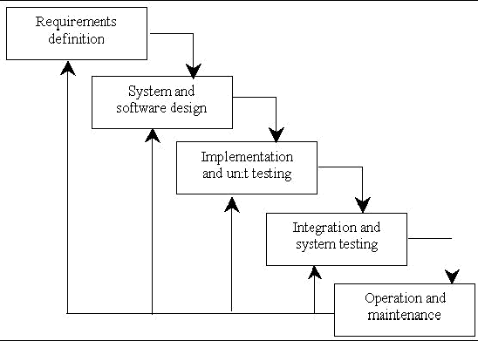

# Figure 3.1: Waterfall Model (www.tutorialpoint.com, 2017)

### 3.3.1 DESCRIPTION OF THE SYSTEM

The information management system for the Department of Computer Science is an online or web-based system that streamlines and automates the department's manual information-sharing procedures. Students can use this system to review notifications, examine outcomes, examine courses, and communicate their opinions with professors (suggestions). Every student has the right to access the system directly.

### 3.4 REQUIREMENT DEFINATION

To comprehend the precise requirements of the proposed system, requirements must be gathered, documented, and extracted. According to K. K. Aggarwal (2008), many functional and non-functional needs were noted for this project. The requirements outline what is expected of the system. The needs are gathered from many sources, as was demonstrated.

### 3.4.1 Functional requirements

The following are some functional requirement of the proposed systems.

1. **Check notifications: Users can check their notifications using the system.**
2. **Send a suggestion: Users can express their thoughts using the system.**
3. **View lectures/courses: Students will look at their lectures and courses.**
4. **Results check: Students will be able to see their outcomes.**
5. **Post alert: The system administrator may post news feeds or any other significant information.**
6. **View suggestion: The system administrator has access to user-submitted suggestions.**
7. **The system administrator has the ability to add and remove courses and lecturers.**

### 3.4.2 Non-Functional Requirements

The following are some non-functional requirement of the proposed systems.

1. The system will be user-friendly, interoperable, versatile, and robust, according to the first attribute of software quality.
2. **Practical:** The system will make it easy for kids to focus.
3. **Responsive:** The system will be quick because its functionality depends on both the hardware itself and the internet's bandwidth.

## 3.5 REQUIREMENTS ANALYSIS

Requirements analysis is a crucial and highly critical activity that comes after requirement elicitation, according to (K. K. Aggarwal, 2008). In order to create consistent and clear needs, we now analyse, improve, and closely examine the acquired requirements. Using a Use Case Diagram, the object-oriented approach will be followed for this project.

**USE CASE DIAGRAM**

**Student (User)**

**Admin**

# Figure 3.2: Use Cases Diagram for the proposed student information system

# DATABASE DESIGN

A database is a data repository that a software system uses. The database contains the data. In order to manipulate the data on the system, several tables are built.

The database's two key settings are as follows:

* Primary Key the field that is unique for all the record occurrences
* Foreign key-the field used to set relation between tables

Normalization is technique to avoid redundancy in the tables.

The individual designing the database is typically knowledgeable about database design but not the source of the stored data. Information on finances, biology, etc.

Therefore, the data stored in the database should be determined in collaboration with someone who has expertise in this field and knows the data that needs to be stored in the system.

For instance, in a list of names and addresses, the addresses are changed according to each person's name, assuming that no one can have more than one address. By supplying the name and list, the address can be uniquely identified. The opposite, however, is untrue. Because numerous persons can reside at one address, even if an address and list are provided, it is impossible to accurately identify the name. Because the name determines the address, it is said to be name dependent.

# TABLE 3.1: LOGIN TABLE

|  |  |  |
| --- | --- | --- |
| **FIELD NAME** | **DATA TYPE** | **CONSTRAINTS** |
| User name | Varchar(50) | Not null |
| Password | Varchar(max) | Not null |

# TABLE 3.2 REGISTERATION TABLE

|  |  |  |
| --- | --- | --- |
| **FIELD NAME** | **DATA TYPE** | **CONSTRAINTS** |
| User name | Varchar(50) | Not null |
| Password | Varchar(max) | Not null |
| Email id | Varchar(10) | Primary key |
| Level | Varchar(20) | Not null |
| Contact number | Int(10) | Not null |

**TABLE 3.3 COURSE TABLE**

|  |  |  |
| --- | --- | --- |
| **FIELD NAME** | **DATA TYPE** | **CONSTRAINTS** |
| Course name | Varchar(50) | Primary key |
| Syllabus | Varchar(max) | Not null |
| Course code | Varchar(50) | Not null |

# CHAPTER 4

**TESTING AND IMPLEMENTATION**

# OBJECTIVE OF TETSING

Software testing is majorly an important portion of the software development life cycle (SDLC) and helps software developers save time and money in the enterprise by finding bugs and flaws early in software development. You can use this process to see the various application-related components and make sure they are appropriate.

There are many software testing goals that, when achieved, help developers create error-free software and applications that demonstrate outstanding performance, quality, effectiveness, and security, among other things. Testing goals vary from company to company and from project to project, but they all have some common goals. These goals are:

* **Validation:** **Validation is one of testing's key objectives. This enables testers to confirm that the software complies with numerous commercial and technical requirements set by the customer before beginning the complete project. For the purpose of directing the design and development of software, certain requirements and standards must be properly followed.**
* **Verification:** Verify that the program performs as anticipated and in accordance with client needs. Verification entails comparing the final result to the anticipated output and making any necessary adjustments if there is a discrepancy.
* **Defects:** The main purpose of testing is to find various bugs in the software and prevent the software from failing or crashing during the implementation or test run of the project. If no errors are detected or unattended, they can affect the functionality of the software and lose resources, money, and customer reputation. Therefore, at every stage of software development, software tests are run regularly to find different types of bugs.
* **Providing Information:** Testers can use the reports generated during the software testing process to collect a variety of information about the software and the steps they have taken to prevent software failures. You can share these with everyone involved in your project to better understand your project and increase transparency among its members.
* **Preventing Defects:** The testicle's objective during the testing procedure is to find flaws and stop further aging. To do this, an impartial tester who is not in charge of software development thoroughly tests the software.
* **• Quality Analysis: By continuously measuring and confirming your design and coding, testing aids in the improvement of the quality of your software.**
* **• Compatibility: This ensures that programs, implementation environments, different devices, operating systems, and user requirements are all compatible with one another.**
* **• To ensure the best user experience: In order for a project to be successful and for client sales to increase, it is essential that both simple access to software and applications and the best user experience be provided. Verification of Performance and Features: Make sure your program has top-notch functionality. To discover and measure all potential failure modes, this is primarily confirmed by subjecting the software to tremendous stress.**
* **Test Plan**: A document that describes the scope, approach, resources, and timing of the intended test activity. Identifies test items, features to test, test tasks to perform each task, tester independence, and more.

# 4.2 TESTING METHODS

Software testing methods are various strategies or approaches used to test an application to ensure that it behaves and displays as expected. These include everything from front-end testing to back-end testing, including unit and system testing.

* Unit testing
* Black- box testing
* White-box testing
* Integration testing
* Output testing

# 4.2.1 Unit Testing

The success of all individual components has been verified using unit tests. Before merging all components, unit testing is crucial to make sure that each one is working correctly on its own and is prepared to be combined with other components.

# 4.2.2 Black Box Testing

The software interface is put to black-box testing. Regardless of the written code, we only tested the functionality in the black-box test. Black-box testing is finished when the component performs as intended.

# 4.2.3 White Box Testing

White-box testing, sometimes known as glass-box testing, is a test case design technique that generates test cases using procedural design control structures. The white-box test examined the internal code created in each component and verified that the code was effectively utilizing the system's various resources, including memory and input and output utilization.

# 4.2.4 Integration Testing

Each unit undergoes extensive testing before being merged with other units to form modules or components made for a certain purpose or activity. To verify that every section of the application performs as planned, these are then verified collectively through integration testing (that is, the interactions between the entities are seamless). These tests frequently involve user scenarios like: B. Open the file or sign into the application, for instance.

# 4.2.5 Output Testing

The output generated or shown by the system under consideration is put to the test when you ask the user for input in the desired format. Here, there are two ways to think about the output format. The other is accurate, whereas the first is displayed on the screen. This is because throughout the system design phase, the format was created taking user requirements into account.

# 4.3 IMPLEMENTATION

You and your project team carry out the project's actual work and deliver results during the implementation phase. Deliverables refer to all of the project's products and services. All items you and your team produce for customers, clients, or sponsors are considered project deliverables, including modified project management documentation. The procedures you follow to produce each deliverable vary depending on the kind of project you are working on, thus they won't be covered in detail here. For instance, projects in engineering and telecommunications concentrate on employing tools, resources, and materials to produce each project's results, whereas projects in computer software concentrate on producing each project's results. It's possible that you'll need to create and use software code routines. The project plan is carried out throughout the execution phase.

# 4.4 TEST CASE REPORT

|  |  |  |  |  |  |  |
| --- | --- | --- | --- | --- | --- | --- |
| **TEST ID** | **TEST CONDITION** | **TEST DESCRIPTIOIN** | **TEST DATA** | **EXPECTED RESULT** | **ACTUAL RESULT** | **FINAL RESULT** |
| Tc 01 | User should enter the user name | User enter valid user name | admin | System should accept the data | System accepts the data | Pass |
|  | User should enter the user name | Admin enter invalid user name | Anu | System should not accept the data | System not accepts the data | Fail |
| Tc 02 | User should enter the password | Admin enters valid password | ****** | System should accept the data | System accepts the data | Pass |
|  | User should enter the password | Admin enters invalid password | ******** | System should not accept the data | System not accepts the data | Fail |
| Tc 03 | User should click the login button | User clicks the login button | log in | System should redirect to the home page | System redirects to the home page | Pass |

**Screen Name: Login**

**Screen Name: User Registration**

|  |  |  |  |  |  |  |
| --- | --- | --- | --- | --- | --- | --- |
| **TEST ID** | **TEST CONDITION** | **TEST DESCRIPTION** | **TEST DATA** | **EXPECTED RESULT** | **ACTUAL RESULT** | **FINAL RESULT** |
| Tc 1 | User should enter details in the registration page | User enters the valid data in the fields | sentil@gmail.com | System should accept the data | System accepts the data | Pass |
|  | User should enter details in registration page | User enters the valid data in the email id fields | Vijay/.gmail.com | Msg displays invalid ail id | Msg displays as invalid mail id | Fail |
| Tc 2 | User should enter data in password and confirm password | User enters the name different data in password and confirm password | “***”, “*****” | Msgdisplays as password mismatch | Msgdisplays as password mismatch | Pass |
| Tc 3 | User should enter the name | User enters the name in the textbox in special characters | “!&^%#@” | System should not accept the data | System accepts the data | Fail |
| Tc 4 | User should click the submit button | User clicks the submit button | submit | System should accept the data | System accepts the data | Pass |
|  | User should click the submit button | User clicks the submit button | submit | System should not accept the data | System not accepts the data | Fail |

**RESULT**

The development of Student Management Information System software was archived using some methods and strategeis. these methods helps in creating the updated version software of Student information Management system. Here are some of the benefits and features of the new software which the software lacks.

**Comparisons between Existed Software and New Software**

**Table 8 Comparisons**

|  |  |
| --- | --- |
| **Existing software** | **New software** |
| The existed software is not effective in terms of logging and maintenance archived. | The new software is more far better than old software in effectiveness and management |
| The old software is time consuming, it takes at least more than 30 seconds to load | The new software is designed to sped up time in less 2seconds |
| It also leads to prone and error | Prone and error process had been minimized |
| It lacks privacy of data and security | Its secures the privacy data of users |
| Retrieval of data takes more than enough time | Retrieval of data doesn’t takes more time to process |
| Percentage of accuracy is less | Accuracy percentage is high |
| It takes a lot of time to generate a report | The new software doesn’t take time to generates report |
| It’s not user friendly | Its attractive and user friendly |
| At times it’s provide the security of page load without log in details. | It doesn’t |
| It doesn’t have any form of AI,ML | It has a voice search space for selecting a blood type |

# CHAPTER 5

**CONCLUSION AND SCOPE FOR FUTURE DEVELOPMENT**

# 5.1 CONCLUSION

The project entitled “STUDENT INFORMATION MANAGEMENGT INFORMATION” was successfully completed with all client requirements. This project has been successfully designed and implemented. This project is designed, tested and finally implemented in a systematic manner.

This project provides the complete information of the student. The user of the system can easily be able to understand how to access. This project is applicable in managing the information of students at the higher institutions.

# 5.2 SCOPE FOR FUTURE DEVELOPMENT

Each application has advantages and disadvantages of its own. Nearly every condition was met by the project. Since the coding is primarily structured or modular in nature, additional requirements and upgrades can be made with ease. Improvements can be added by altering the current modules or adding new modules. Additional application improvements could be done to make the website perform in a far more appealing and practical way than it does now.

**REFERENCES**

Azarm-Daigle, M., Kuziemsky, C., & Peyton, L. (2015). A Review of Cross Organizational Healthcare Data Sharing. *Procedia Computer Science* , 425 – 432.

Ercan, T. (2010). Effective use of cloud computing in educational institutions. *Procedia Social and Behavioral Sciences*, 938–942.

Jayant, B., & Bhise, A. S. (2016). Developing A Secure Cloud Storage System for Storing IoT Data by Applying Role Based Encryption. *Procedia Computer Science*, 43 – 50.

JENNIFER, E. E. (2018). *DESIGN AND IMPLEMENTATION OF ACADEMIC MANAGEMENT SOFTWARE USING RELATIONAL DATABASE AND HTTP SEVER.* OWERRI.

Jouini, M., & Ben Arfa Rabai, L. (2016). Comparative Study of Information Security Risk. *Procedia Computer Science*, 1084 – 1089.

K. K. Aggarwal, Y. S. (2008). *Software Engeering* (Third Edition ed.). Daryaganj, New Delhi: New International Publishers.

Sommerville, I. (2011). *Software Engineering* (9th edition ed.). New York: Addison-Wesley.

Almahdi Alshareef, Ahmed Alkilany "Toward a Student Information System for Sebha University, Libya”, Fifth international Conference on Innovative Computing Technology (INTECH 2015)-p 34-39

Prabhu T Kannan, Srividya K Bansal, “Unimate: A Student Information System", 2013 International Conference on Advances in Computing, Communications and Informatics (ICACCI)-p-1251-1256

Student specific Information System. (US20120237917A1)

# APPENDICES

# APPENDIX-1 SAMPLE SOURCE CODE

# LOGIN PAGE

<!DOCTYPE html>

<?php

    session_start();

    if (isset($_POST['student_login'])) {

        echo"<script>alert('hello')</script>";

        $connection = new MySQLi( 'localhost', 'root', '', 'compsci_dept' );

        $username = $connection->real_escape_string( $_POST['username'] );

        $password = $connection->real_escape_string( $_POST['password'] );

    $query = "SELECT * FROM `student_table` WHERE `email`='$username' AND `reg`='$password' ";

    if ( ($results = $connection->query( $query ) ) == true ) {

        if ( $connection->num_rows > 0 ) {

            $arr = $results->fetch_assoc();

            $_SESSION['user_id'] = $arr['id'];

            $_SESSION['username'] = $arr['email'];

            $_SESSION['password'] = $arr['reg'];

            header("Location:index.php");

            exit();

        }

        else {

           session_destroy();

            header("Location:index.php");

            exit();

        }

    }

    //

}

**REGISTER PAGE**

<html>

<head>

<title>registration form</title>

</head>

<body style="background-color:pink;">

<center>

<h3> registration here </h3>

<form action =" " method =" ">

<tr>

<td>username :< /td>

<td><input type ="text" placeholder="user" name="">

</td>

</tr>

<ol></ol>

<tr>

<td>password :</td>

<td><input type = "password" placeholder = "password" name="">

</td>

</tr>

<ol></ol>

<tr>

<td>Email: </td>

<td>

<input type= "email" name="mail"

placeholder ="enter email here">

</td>

</tr>

<ol></ol>

<tr>

<td>phone: </td>

<td><input type ="phone" name=""></td>

</tr>

<ol></ol>

<tr>

<td><a href="img.html"><button>submit</button></a></td>

<td>Already a user?<a href = "pro1.html">

login here</a></td>

</tr>

<ol></ol>

</center>

</table>

</body>

</html>

**HOME PAGE**

<!DOCTYPE html>

<?php

    session_start();

    if ( !( isset( $_SESSION['comp']['login']['id'] ) || !empty( $_SESSION['comp']['login']['id'] ) ) ) {

        header("Location:administrator.php");

    }

    include( "php/staff_function.php" );

    include( "php/student_function.php" );

    include( "php/course_function.php" );

    include( "php/result_function.php" );

    include( "php/home_function.php" );

?>

<html>

<head>

    <meta charset="utf-8">

    <title>Super User :: Logged in</title>

    <link rel="stylesheet" type="text/css" href="stylesheet/homeDefault.css" />

    <style type="text/css">

        .staffCov { border-bottom:1px solid #aaa; padding:4px; font-size:11px;}

        .staffCov_ { border-bottom:1px solid #aaa; padding:4px; font-size:11px; FONT-WEIGHT: BOLD;}

        .staffCov:nth-child(even) { background:rgba(240,240,240,1); }

        .staffCov:hover { background:rgba( 200,200,200,1);}

        .sNo, .fullName, .stId, .courseLect,

        .sex, .rank, .contact1, .courseLevel,

        .contact2, .trash, .float_date,

        .float_suggest, .courseName, .creditLoad {float:left; height:20px; }

        .sNo {width:24px; text-align:right; padding-right:4px;}

        .fullName {width:200px; text-align:left; padding-left:4px; overflow:hidden;}

        .courseName {width:170px; text-align:left; padding-left:4px; overflow:hidden;}

        .stId {width:70px; text-align:left; padding-left:4px; overflow:hidden;}

        .sex { width:50px; text-align:left; padding-left:4px; overflow:hidden;}

        .creditLoad { width:30px; text-align:left; padding-left:4px; overflow:hidden;}

        .rank { width:110px; text-align:left; padding-left:4px; overflow:hidden;}

        .courseLevel { width:70px; text-align:center; padding-left:4px; overflow:hidden;}

        .courseLect { width:100px; text-align:left; padding-left:4px; overflow:hidden;}

        .float_suggest { font-size: 13px; width: 300px; height: auto; padding-left: 10px; }

        .float_date { width: 150px; text-align:center; color: #630; }

        .trash { width:20px; overflow:hidden; }

            .trash a { display:block; width:20px; height: 20px; overflow:hidden; background-image: url('images/trash.png'); }

        form[name="addStaff"] { padding-top: 20px; }

        label.login_label { width: 140px; float: left; text-align: right; font-size: 13px; padding: 8px 4px 0 0; color: #094;  cursor: pointer; }

            input.logger { width: 180px; display: block; margin-bottom: 12px; padding: 8px; border-radius: 5px; border: 1px solid #ccc; cursor: pointer; }

            input.short_logger { width: 62px; display: block; margin-bottom: 12px; padding: 8px; border-radius: 5px; border: 1px solid #ccc; cursor: pointer; }

            input.short_logger:focus { cursor: text; }

            select.addSelector { width: 80px; display: block; margin-bottom: 12px; padding: 8px; border-

    </style>

    <style type="text/css">

        #containSearch { border-bottom: 1px dotted #084; padding-bottom: 20px; margin-bottom: 20px;  }

        #resultSearchBar { font-size: 12px; padding: 8px; width: 300px; border: none; border-radius: 4px; box-shadow: inset rgba( 0,0,0, 0.6 ) 1px 1px 5px ; font-size: 11px;

        #resultSplitter { margin-top: 20px; border: 1px dotted #084; padding: 24px 10px; border-radius: 8px; }

            #addResultForm, #studentSelector { float: left; }

            #studentSelector { width:200px; }

                #studentSelector select { width: 140px; margin-left: 50px; }

            #addResultForm {}

                       select#studentDropDown { padding: 7px; border-radius: 6px; box-shadow: inset rgba( 0,0,0, 0.6 ) 1px 1px 5px ; border: 0; }

                       #submitHolder { text-align: center; padding-top: 20px; }

            input[name='submitResult'] {  }

        div.studentRegHolder { font-family: arial; font-size: 13px; font-weight: bold; margin-bottom: 10px; color: #048; border-bottom: 1px solid #048; }

        #resultDisplay { min-height: 160px; }

        .singleYearResult { margin-bottom: 10px; }

        .yearTitle { border-bottom: 3px solid #c8c8c8; padding: 6px; font-size: 13px; font-weight: bold; }

        .resultBox { float: right; min-height:40px; width: 500px; }

        .semester_1, .semester_2 { float: left; width: 250px; }

            .header_s { padding: 4px 0 2px 10px; font-weight: bolder; border-bottom: 1px solid #eee; }

            .call_result, .resp_result { float: left; height: 13px; padding: 6px;  }

            .call_result { width: 100px; padding-right: 10px; text-align: right; }

            .resp_result { color: #064; font-weight: bold; }

    </style>

    <style type="text/css">

        textarea.logger_notice { height: 50px; }

        div.submitterBox { text-align: center; }

        fieldset.addANote { border: 1px solid #ccc; border-radius:6px; margin-bottom: 20px; }

        fieldset.addANote legend { margin-left: 20px; }

    </style>

</head>

<body>

    <div id="NNTWAA"><div id="tabbedPane">

            <a href="home.php?pageinfo=home">HOME</a>

            <a href="home.php?pageinfo=staff">STAFF</a>

            <a href="home.php?pageinfo=students">STUDENTS</a>

            <a href="home.php?pageinfo=courses">COURSES</a>

            <a href="home.php?pageinfo=results">RESULTS</a>

            <a href="home.php?pageinfo=notice">NOTICE</a>

            <a href="home.php?pageinfo=suggestion">SUGGESTIONS</a>

        </div>

        <div id="pageInsertion">

            <?php

                if ( isset($_GET['pageinfo']) && !empty($_GET['pageinfo']) ) {

                    switch( $_GET['pageinfo'] ) {

                        case 'staff':

                            getStaffPage();

                                break;

                        case 'students':

                            getStudentPage();

                                break;

                        case 'courses':

                            getCoursesPage();

                                break;

                        case 'results':

                            getResultPage();

                                break;

                        case 'notice':

                            getNoticeAdmin();

                                break;

                        case 'suggestion':

                            getSuggestions();

                                break;

                        default:

                            getDefaultHome();

                    }

                }

                else {

                    getDefaultHome();

                }

            ?>

            <div id="escapeString"><a href="logout.php">Logout </a></div>

        </div>

    </div>

</body>

**APPENDIX-2**

**SAMPLE SCREEN SHOTS**

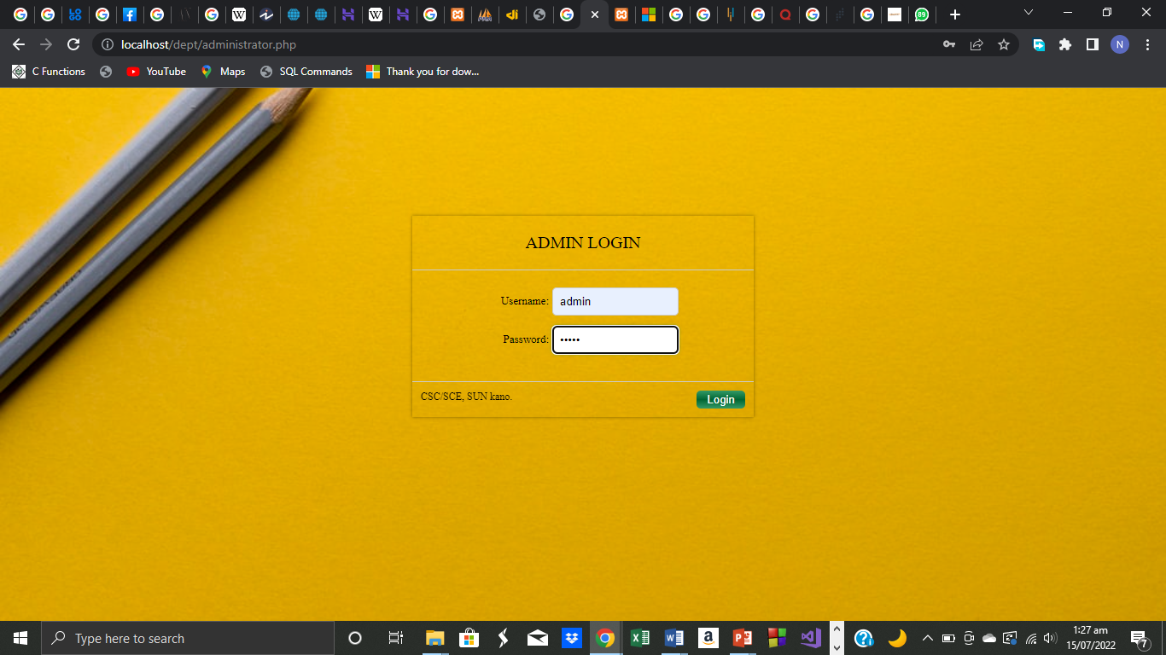

**FIGURE A 2.1 ADMIN LOGIN PAGE**

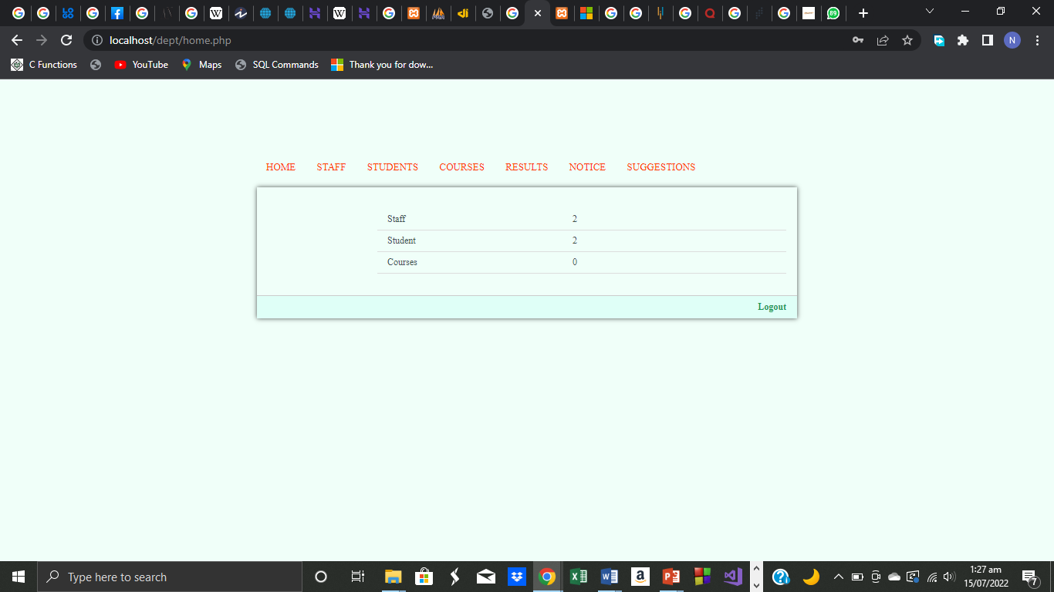

**FIGURE A 2.2 ADMIN HOME PAGE**

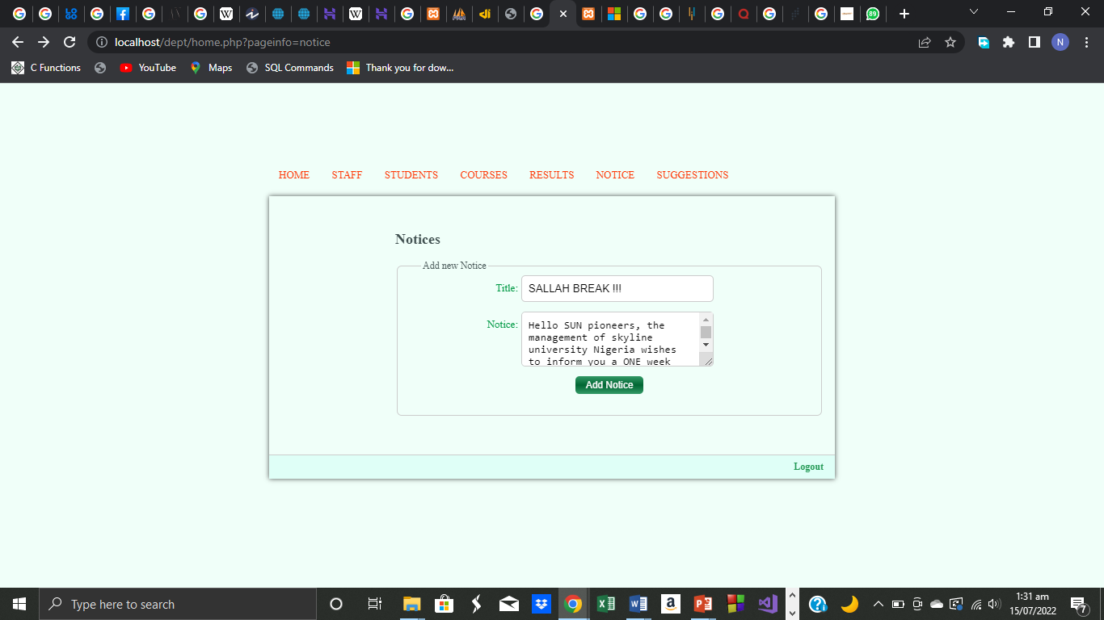

**FIGURE A 2.3 ADMIN NOTICE BOARD**

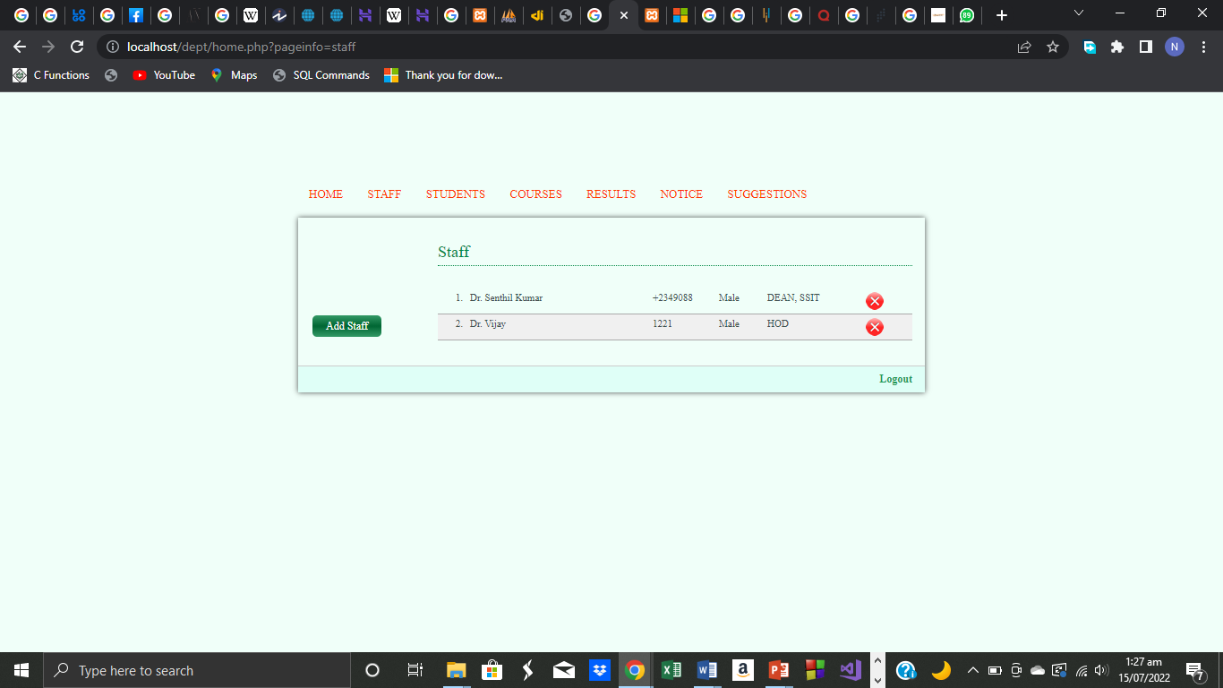

**FIGURE A 2.4 ADMIN STAFFS TABLE**

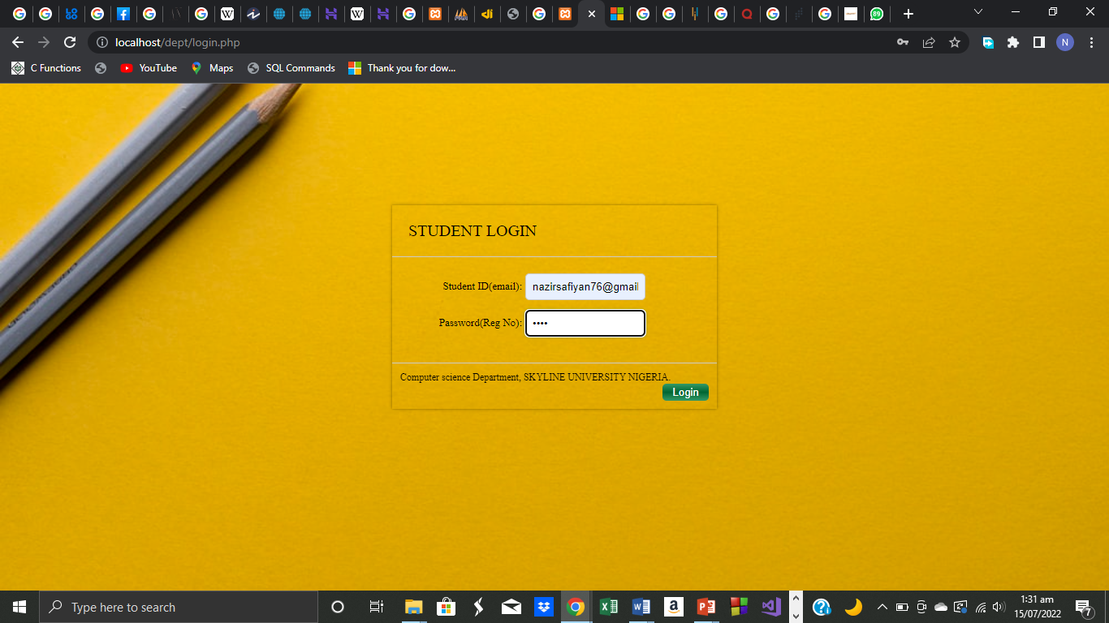

**FIGURE A 2.5 STUDENT LOGIN PAGE**

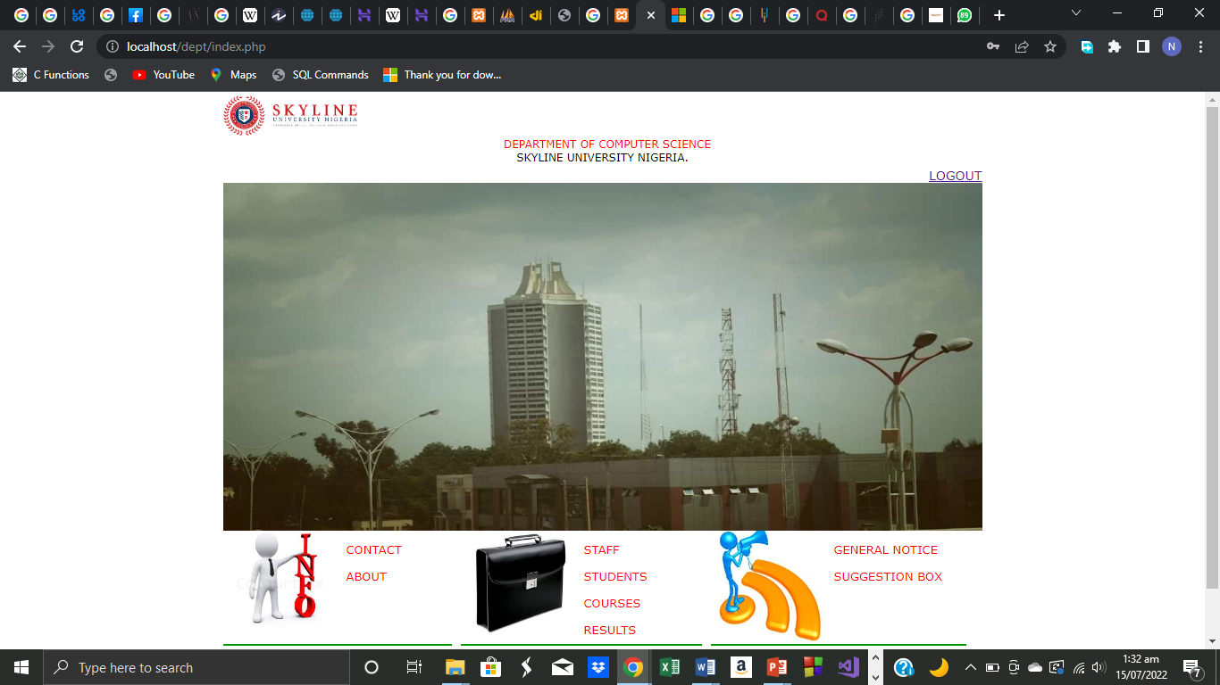

**FIGURE A 2.6 STUDENTS HOME PAGE**

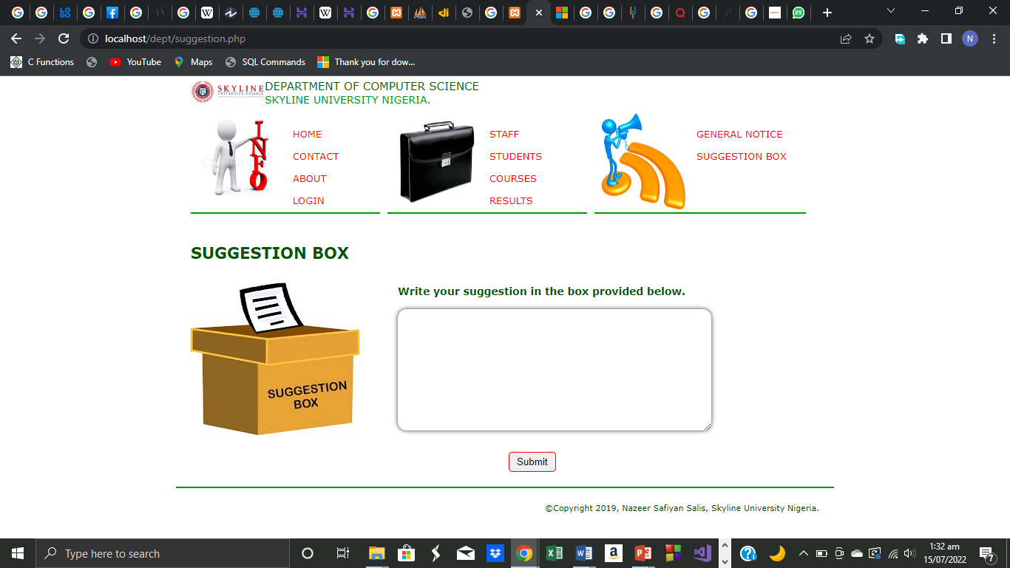

**FIGURE A 2.7 STUDENTS SUGGESTION BOX**

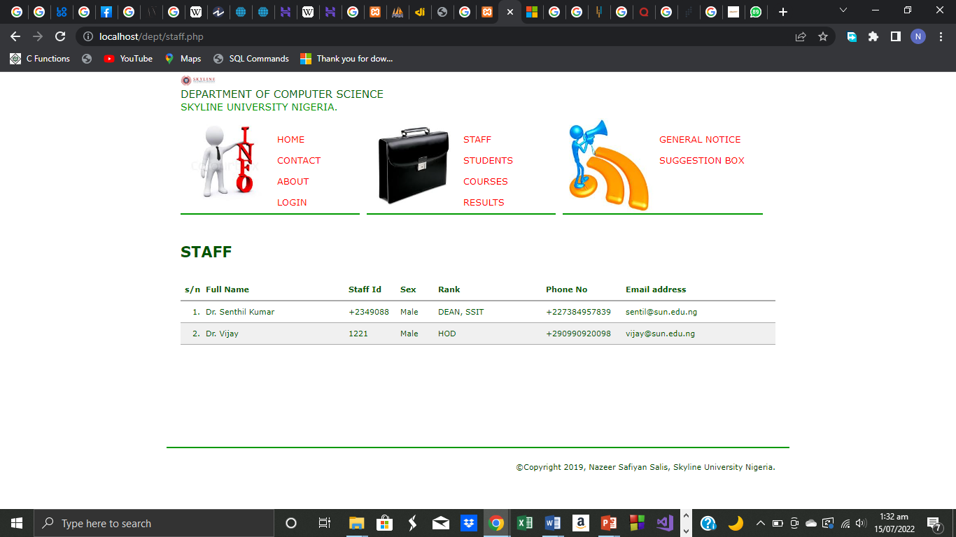

**FIGURE A 2.8 STUDENTS STAFF VIEW**